DISCOVER THE **DIFFERENT SIDES** OF STRASBURG

Discover 2025

|  |
| --- |
| Strasburg, VA |
|  |

|  |
| --- |
| **Discover 2025**  "Strasburg is a town defined by its geography and enriched by its natural environment. Our historic planned town and its original design connects our people to each other and provides a map for future growth. We understand that unity provides a framework to shape destiny that we carefully manage. We envision a future where the town inspires individuals to define the aspects of life that matter most to them.    Strasburg will identify the resources needed to facilitate the dreams of its citizenry. Prosperity will continue to flourish and include a diversity of knowledge and experience and the freedom to express our ideas. Every citizen possesses the opportunity to access and influence governmental decisions that influence their future."      Figure 1: Kayaking on the Shenandoah River |

**Table of Contents**

Executive Summary 4

Key Findings **Error! Bookmark not defined.**

Business Development 4

Quality of Life 7

Introduction 8

Project Team 9

Review of Other Plans 10

A Plan for Downtown Strasburg, 2012 10

Market Analysis for the Town of Strasburg, 2012 10

Downtown Economic Restructuring Plan, 2014 10

Northern Shenandoah Business Park Development Plan, 2016 11

Strasburg Comprehensive Plan, 2018 11

Appendix A: Strasburg Town Council Goals and Strategies 12

Appendix B: SWOT Analysis 13

Appendix C: Demographic and Socioeconomic Profile and Summary 15

Demographics 15

Population Characteristics 15

16

Economics 17

Educational Attainment 18

Housing 19

Cost of Living 20

Commuter Trends and Job Counts 20

Industry Profile 23

Occupation Profile 25

Connectivity 26

Internet Infrastructure 26

Road Network 26

Real Estate 27

Appendix D: Retail Analysis 29

Retail Leakage Report 29

Tapestry Segmentation 31

Appendix E: Discover 2025 Action Plan 33

Appendix F: Maps 34

**List of Tables and Figures**

Table 1: Business Development Action Plan 6

Table 2: Quality of Life Action Plan 7

Table 3: Town Council Goals and Strategies Matrix 12

Table 4: SWOT Analysis 13

Table 5: Demographic Overview 15

Table 6: Population Comparison by Locality 15

Table 7: Population by Gender, Strasburg 14

Table 8: Population by Race, Strasburg 15

Table 9: Labor Force Participation in Shenandoah County 17

Table 10: Educational Attainment by Locality 18

Table 11: Number of Housing Units by Locality 19

Table 12: Median House Value by Locality 19

Table 13: Rental Vacancy by Locality 19

Table 14: Cost of Living Matrix 20

Table 15: Commute Times by Locality 20

Table 16: Internal Trip Capture, Outflow Characteristics 21

Table 17: Internal Trip Capture, Inflow Characteristics 22

Table 18: Internal Trip Capture, Interior Characteristics 22

Table 19: Industry Profile, Strasburg 24

Table 20: Occupation Profile, Strasburg 25

Table 21: Retail Leakage by Locality 30

Table 22: Tapestry Segment Distribution 31

Figure 1: 'Shenandoah' mural by Over Under 1

Figure 2: Downtown Strasburg 8

Figure 3: Downtown Intersection 9

Figure 4: Population by Gender Comparison by Locality 14

Figure 5: Age Distribution Comparison by Locality 14

Figure 6: Age Distribution, Town of Strasburg 14

Figure 7: Population by Race Comparison by Locality 15

Figure 8: Median Household Income by Locality 16

Figure 9: Per Capita Income by Locality 16

Figure 10: Households by Income, Strasburg 16

Figure 11: Educational Attainment, Strasburg 18

Figure 12: Housing Occupancy by Locality 19

Figure 13: Internal Trip Capture 21

Figure 14: Shenandoah River + View of Signal Knob Mountain 23

Figure 15: Clementine Vintage 23

Figure 16: Population Density Map, Strasburg 34

Figure 17: Zoning Map, Strasburg 35

Figure 18: Daily Traffic Volume Map 36

# Executive Summary

To achieve the action plan, the expanded community advisory team started with an analysis of demographic, economic, and geographic data from a variety of sources including databases for which NSVRC maintains paid subscriptions: Esri and JobsEQ. The data were reviewed with the project team prior to organizing a discussion on the strengths, weaknesses, opportunities, and challenges for the Strasburg community. The data and SWOT were paired to identify high potential strategies. Strengths were matched with opportunities and challenges to form action items for the plan. The action plan is tightly aligned with Town Council’s strategic plan.

The full list of identified strengths, weaknesses, opportunities, and challenges/threats can be found in Appendix B of Discover 2025.

**Notable Strengths:**

* The small business community is active and supportive of the greater community.
* Town supports a vibrant quality of life focused on the arts, culture, and creativity, that in turn allows for great pride in community.
* There are sites/land available for recreational and/or industrial development.

**Key Weaknesses:**

* Lack of shared community spaces and coworking spaces.
* Full inventory of available land and sites are not easily found on commercial real estate databases.
* Lack of public transportation where approximately 100 households have no car.
* Lack of available diverse housing types.

**Opportunities**

* Focus on creating a community that supports workforce, capitalize on the opportunity to capture telework employees who will tend to opt for these jobs with a higher concern for quality of life and recreation over wages and benefits.
* Prepare for mixed use development that could create space for living, working, and shopping.
* County services accessibility and department accreditation that could ease processes for businesses in Strasburg.

**Threats**

* Aggressive residential and economic development in neighboring Frederick County.
* High speed internet availability in surrounding small towns could draw population away.
* Retail leakage to Winchester, Front Royal, and Harrisonburg

The top three occupations by current employment in Strasburg are Production (723), Office and Administrative (352), and Transportation and Material Moving (290). Sales, Food Preparation, and Serving related occupations total 460 employed. Over the next five years, total employment is expected to be stable, with an overall employment change of -0.1%. High growth occupations by percent annual change are in Health Care Support, Personal Care and Service, Health Care Practitioners, and Community and Social Service. Employment characteristics by occupation align with employment characteristics by industry with the highest employment in Manufacturing, Accommodation & Food Services, Retail Trade, and Transportation & Warehousing. Additional details of the economic characteristics of the Town can be found in Appendix C, beginning on page 18.

After reviewing the Esri retail leakage report for opportunities to increase the retail expenditures in Strasburg, the strategy team opted to focus on attraction and development of restaurants and retail in general. Details on broad retail categories for which there are surplus and deficits in retail expenditures can be found in Appendix D. Appendix D also details the Tapestry Segmentation, this is a unique way to categorize a population down to the neighborhood, by demographic and socioeconomic characteristics which help to identify customers, optimal sites, and underserved markets. More than 40% of Strasburg’s population is classified as “Middleburg” followed by “Heartland Communities” at 26%. These two segments are quite similar. They vary most in median age, where Heartland Communities tend to be about 6 years older and median household income where Heartland communities come in at about $17,000 less. Both segments prefer to purchase American made products, modest and affordable housing types, drive trucks & SUVs, and spend money on recreation including hunting and fishing. The third largest Tapestry Segmentation for Strasburg are the “Front Porches” this segment is requires more variety in housing types and the opportunity to rent and is characterized by blue collar workers with high labor force participation rate. Front Porches also seek adventure and outdoor recreation.

In addition to what is presented here, Discover 2025 includes a review of previous plans for the last 10 years. This review provided the insight that Strasburg is capable and committed to executing a strategic plan, very few recommendations and strategies have been left incomplete. Where they were not completed, strategies or action items that are still relevant were considered for including in this action plan.

Through the Discover 2025 Action Plan, Strasburg will be able to enhance the quality of life and diversify the local economy, supporting residents and businesses alike.

### Business Development

Table 1: Business Development Action Plan

|  |
| --- |
| Goal 1 | Prosper: Maintain a thriving town with business and job opportunities |
| **Strategy 1 | Improve existing hard and soft infrastructure**   * Consider the ongoing façade program * Increase start-up business resources (process ease, information, courses, resources) |
| **Strategy 2 | Enhance the foundation for job and economic growth for the town** |
| * Consider incentives to attract targeted businesses for economic growth * Develop recruitment strategy/materials for targeted retail and restaurants * Enhance the visibility of sites and buildings * Increase efforts with existing businesses |
| **Strategy 3 | Create enhanced quality of life to retain current residents and attract new ones** |
| * Consider beautification strategy and additional volunteer campaigns that will engage businesses citizens and volunteers to enhance community spirit |
| **Strategy 4 | Foster economic development efforts through tourism** |
| * Encourage professional services to locate above street level so that storefront may be used for retail and food service |
| **Strategy 5 | Foster creative development**   * Identify priority space for development * Establish a cohort of makers, entrepreneurs, and artisans in need of space * Determine equipment needs based on use type |
|  |
| Goal 2 | Protect: Preserve our unique small-town character and natural environment |
| Goal 3 | Plan: Maintain our legacy of careful planning for the future of our town |
| **Strategy 1 | Encourage a diversity of housing types to accommodate the needs and preferences of current and future town residents** |
| Goal 4 | Strengthen: Support the health of our town by providing resources for recreation and healthy activities |
| **Strategy 1 | Foster the development of local food systems to support agriculture, entrepreneurship, and access to healthy foods** |
|  |

### Quality of Life

Table 2: Quality of Life Action Plan

|  |
| --- |
| Goal 1 | Prosper: Maintain a thriving town with business and job opportunities |
| **Strategy 1 | Improve existing hard and soft infrastructure** |
| * Main street Wi-Fi, increase network connectivity in commercial areas |
| Goal 2 | Protect: Preserve our unique small-town character and natural environment |
| **Strategy 1 | Implement policies and actions that protect the town’s historic character and natural resources**   * Consider strategies for renovating substantial buildings in town |
| Goal 3 | Plan: Maintain our legacy of careful planning for the future of our town |
| **Strategy 1 | Encourage a diversity of housing types to accommodate the needs and preferences of current and future town residents**   * Gather data and develop educational materials on density, housing types. Identify potential challenges * Identify stalled housing development projects and negotiate inclusion of mixed income housing * Establish a connection with a community housing development organization like People Inc or Habitat for Humanity |
| Goal 4 | Strengthen: Support the health of our town by providing resources for recreation and healthy activities |
| **Strategy 1 – Improve the accessibility to natural resources in the town and surrounding area** |
| * Increase river usage, promotion, and education |
| **Strategy 2 – Enhance the recreational opportunities, maintenance, and improvements in the town’s park and public spaces** |
| * Create trail connections between major hubs around town including river access points, Signal Knob, housing developments and neighborhoods, downtown, and Rt. 11 |
| **Strategy 3 – Consider adoption of policies, programs, and practices that encourage healthy behavior and choices** |
| * Explore the use of paramedics for well care and non-emergent medical issues to limit emergency department traffic and unpaid medical transport bills * Engage Shenandoah county public schools and Shenandoah county parks and recreations to produce and promote a wellness campaign to include physical and mental wellness * Provide resources for substance abuse prevention and education. |

# Introduction

In 2019, the Town of Strasburg contracted with the Northern Shenandoah Valley Regional Commission to update and expand the current Downtown Plan. In April NSVRC staff attended the Community Advisory Team meeting to discuss the project. Unanimously, the group voted to expand the scope of the Downtown Plan to include additional areas of interest, particularly areas zoned highway commercial and community commercial to the north of Downtown along U.S. Route 11 and State Route 55. With the expansion of the scope of the plan, the Community Advisory Team appropriately expanded the project team to include members of the planning commission and County economic development staff, and representatives from additional community segments. The new, expanded, project team engaged in a multi-disciplinary approach, including data-based and issue-oriented planning over the course of five months, with four team meetings. The Team participated in a Strengths, Weaknesses, Opportunities and Threats (Challenges) assessment; reviewed and discussed socioeconomic, industry, occupation, and retail data; and identified priority issues. NSVRC Staff compiled all information and presented recommendations on strategies to attain the goals. The project team further reviewed those recommendations to identify appropriate action items.

Through the Discover 2025 Action Plan, Strasburg will be able to enhance the quality of life and diversify the local economy, supporting residents and businesses alike.

The Discover 2025 project team did not develop a new vision for this plan update, but instead takes its direction first and foremost from the vision statement developed by the Strasburg Town Council and applies the focus statement above for strategic direction. Additionally, the plan will include references and responses to the Town’s Priorities Matrix, developed in May 2019. Refer to Appendix A for Town Council’s Vision and priorities details.

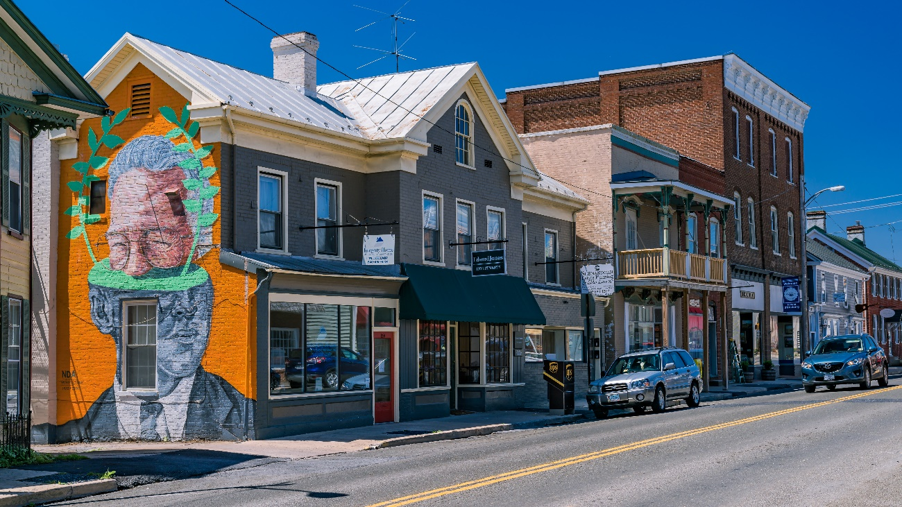

Figure 2: Downtown Strasburg

## Project Team

|  |  |
| --- | --- |
|  | |
| Andrew Keller | Longtime Resident Representative |
| Ashley Shickle | NSVRC Representative |
| Barbara Plitt | Arts and Culture Representative |
| Karen Taylor | NSVRC Representative |
| Michelle Bixler | Director of Community Development, Strasburg |
| Olivia Hilton | Community Development Coordinator, Strasburg |
| Rev. John B. Haynes | Faith Community Representative |
| Rich Orndorff | Former Mayor, Strasburg |
| Scott Terndrup | Former Vice Mayor, Strasburg |
| Susan Haynes | Commercial/Corridor Business Owner Representative |
| Teresa Orndorff | Financial Institute Representative |
| Timothy Taylor | Strasburg Heritage Association Representative |
| Viviana Keffer | Lodging Representative |
| Wyatt Pearson | Town Manager, Strasburg |
| bob flannigan | Planning Commission, Strasburg |
| Butch Barnes | Sager Real Estate, Real Estate |
| Emily Reynolds | Town Council Member, Strasburg |
| Jenna French | Shenandoah County Economic Development |

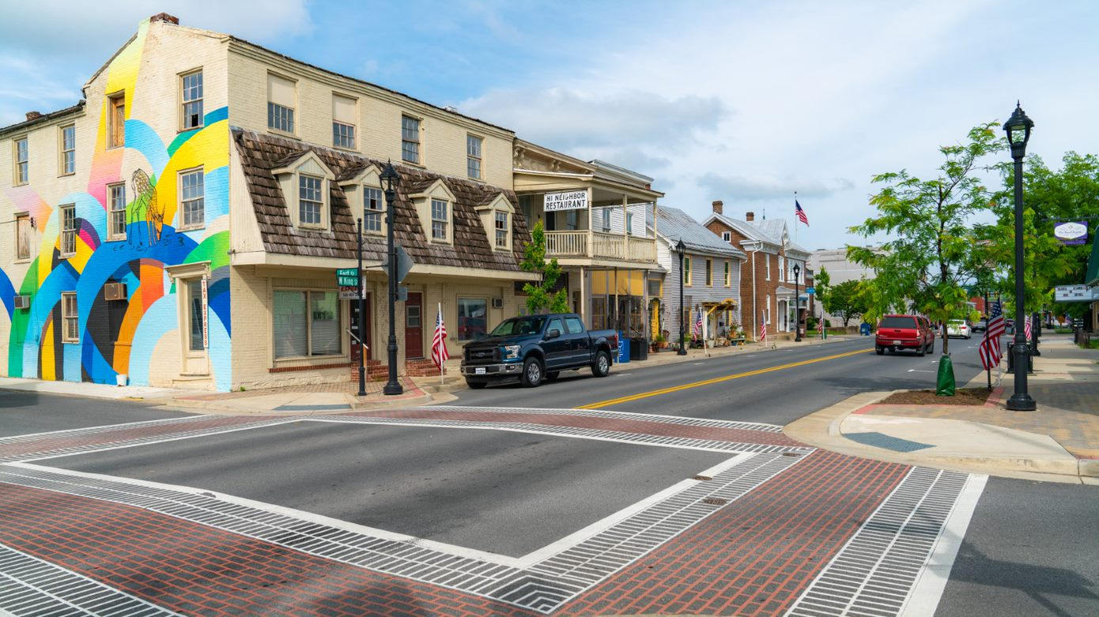

Figure 3: Downtown Intersection

# Review of Other Plans

## A Plan for Downtown Strasburg, 2012

Six goals and strategies were outlined in the Strasburg Downtown Plan in 2012. Many of the strategic elements of A Plan for Downtown Strasburg have been The Community Advisory Team was established, and the economic development staff position was created and filled, a unified brand including a social media presence for the Town of Strasburg was developed and implemented, multiple community sponsored events are in place, the Street Scape project is underway, a green space is open downtown adjacent to the town building, and many of the food establishment vacancies have been filled.

Strengthening the connectedness of the Town beyond Downtown limits remains a priority. In 2020, the Town established a sidewalk corridor to connect downtown to Gateway plaza. This created a walkable route to shopping and food stores.

There are opportunities and interest in evaluating the fitness of the remaining strategies and implementing them if they are still relevant. Opportunities remain in engaging the town youth and business recruitment.

### Market Analysis for the Town of Strasburg, 2012

Retail comparisons were made between Strasburg and five additional communities in Virginia and the Shenandoah Valley, of roughly the same population (Bedford, Buena Vista, Stuarts Draft, Woodstock, and Wytheville). The analysis recommended several retail and food options to attract to the Downtown area. Strasburg celebrated the location of a brewery, ice cream parlor, novelty and secondhand retail, and additional lodging.

### Downtown Economic Restructuring Plan, 2014

This report presented a three-part plan.

Part 1: Economic Restructuring Analysis presented 13 weaknesses and challenges, and associated strategies for strengthening and mitigating. As with the Plan for Downtown Strasburg, many of the strategies in this plan have been implemented, and some of the challenges remain unmet. Since studies in this report were completed, the restaurant mix has grown to include 2 breweries, a new coffee shop, and a new Mexican restaurant; downtown businesses are keeping more regular hours and participating in Main Street events with extended hours on event days. The Town has completed a façade improvement program through a public private partnership with Downtown businesses, Strasburg, and DHCD. The Downtown Greenspace is open and live outdoor events have taken place throughout the summer of 2019. In response to the parking challenge, the Washington Lot adjacent to King Street was redesigned, increasing accessibility and safety.

Part 2: Business Recruitment Strategy and Marketing presented 9 strategies to enhance business development primarily through entrepreneurship and recruitment.

Part 3: Capital Improvements Priorities presented the three main areas on concern. Of the three capital improvement priorities presented, none have been left untouched.

Four formal recommendations were made at the end of the plan:

1. Continue planning and assembling and commit matching funds for a CDBG Block Grant through DHCD. The first round of this grant had recently concluded.

2. Develop the Public Park, Enhance Public Parking, and develop a connecting trail. Currently a “Master Park Plan” is beginning and further recommendations on parks will be found within that plan.

3. Build a robust Business Recruitment Strategy focusing on Entrepreneurship. The funds suggested for use in the plan were not sought, and business growth has remained organic versus intentional.

4. Pursue a marketing approach that emphasized crossroads location. It was determined not to be the best approach for the town, and therefore not pursued.

### Northern Shenandoah Business Park Development Plan, 2016

This plan focuses on potential buildouts of the park to meet the Town’s desired development outcomes. The report makes clear that the Northern Shenandoah Business Park (NSBP) and the Downtown and other residential and commercial areas will support the NSBP by attracting the most desirable workforce. the Camoin Team identified the target sectors for the NSBP, identified potential barriers to development and recruitment, and recommended strategies to market Strasburg effectively. Recommendation within “Discover 2025” will support the four marketing recommendations in Appendix L of NSBP Plan.

### Strasburg Comprehensive Plan, 2018

The mandatory update of the Comprehensive plan began in 2016 as the Northern Shenandoah Business Park Plan was wrapping up and considers that plan along with the Long-Range Transportation Plan and others when setting the expectations for future land use and development.

# Appendix A: Strasburg Town Council Goals and Strategies

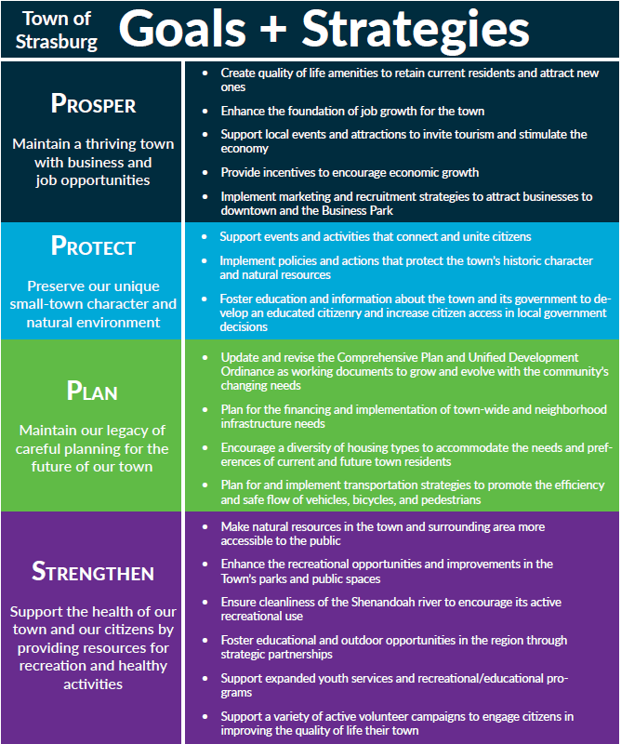

Table 3: Town Council Goals and Strategies Matrix

# Appendix B: SWOT Analysis

The following table identifies the strengths, weaknesses, opportunities, challenges, and threats that inform growth and development in the Town of Strasburg.

Table 4: SWOT Analysis

|  |  |  |  |
| --- | --- | --- | --- |
| Strengths | | Weaknesses | |
| S1 | Multiple properties poised for redevelopment | W1 | Industrial park sites not pad-ready |
| S2 | Social media presence | W2 | Lack of shared community spaces |
| S3 | Major transportation routes (e.g., I 81 and I 66) | W3 | Lack of public transportation |
| S4 | Existence of and County EDA investments into Northern Shenandoah Industrial Park | W4 | Walkability, in need of sidewalks, etc.… |
| S5 | Presence of the Shenandoah River | W5 | River access points limited |
| S6 | New housing developments (approx. 350 units between 2) | W6 | Need for “Workforce housing” |
| S7 | Pride in community | W7 | Accessibility of vocational/specialized training |
| S7 | Events | W8 | Perception that Shenandoah County and Strasburg are not “business friendly” |
| S9 | Small business | W9 | Lack of community resources for aging-in-place |
| S10 | Shenandoah County Chamber of Commerce workforce study | W10 | Social media gossip and negative perceptions |
| S11 | Shenandoah County economic development strategic planning, Master Park Plan, Northern Shenandoah Industrial Park plan, Transportation Study | W11 | Route 11 transportation link (originally an opportunity) |
| S12 | Arts and culture/creativity | W12 | Lack of childcare options (originally a threat) |
| S13 | Shentel in Shenandoah county providing connectivity for businesses and residents, high speed internet for businesses | W13 | County offices in Woodstock, Strasburg professional services and food service/retail miss out on opportunities (originally an opportunity) |
| S14 | Quality of life and cost of living | W14 | Lack of co-working space |
| S15 | Collaborative mindset of government, business, and non-profit organizations | W15 | Employment opportunities limited (originally a threat) |
| S16 | Gateway to the Shenandoah Valley (originally an opportunity) | W16 | Hotel Strasburg is outdated |
| S17 | Boutique Hotel - Hotel Strasburg | W17 | Few commercial vacancies |
| S18 | Land available for attractions or development | W18 | No pad ready commercial sites |
|  |  | W19 | Available sites not visible, only some are listed on LoopNet |
|  |  | W20 | 3.3 % of household have no car |

|  |  |  |  |
| --- | --- | --- | --- |
| Opportunities | | Challenges and Threats | |
| O1 | Telework employees | C1 | Aggressive residential and economic development in neighboring Frederick County |
| O2 | Shenandoah National Park tourism | C2 | Over population of schools |
| O3 | Pass through traffic on Route 11 | C3 | Businesses downsizing |
| O4 | Workforce chooses jobs based on quality of life over wages and benefits | C4 | Automation of manufacturing work |
| O5 | Shenandoah University and Lord Fairfax Community College | C5 | Changes to the scope of manufacturing jobs, little known about future needs |
| O6 | County services accessibility | C6 | Aging workforce |
| O7 | Healthcare accessibility – Sentara, Inova, Valley Health | T7 | School ratings on real estate sites |
| O8 | Trend toward workforce pipeline development (SCHEV, VCCS, LFCC program development opportunities) | T8 | High speed internet availability in other towns like Strasburg |
| O9 | Department accreditation | T9 | Fishers Hill Hiking Path |
| O10 | Mixed use development | T10 | Retail leakage to Winchester, Front Royal, Harrisonburg continues |

# Appendix C: Demographic and Socioeconomic Profile and Summary

This section provides a well-rounded overview of the demographic and socioeconomic condition of Strasburg. Unless otherwise noted, data analysis comes from 2013-2017 American Community Survey estimates of the 2010 Census. Comparison data are provided for Shenandoah County, Virginia, and the U.S.

## Demographics

Table 5: Demographic Overview

|  |  |  |  |
| --- | --- | --- | --- |
| 2017 Population | Median Household Income | Median Age | Housing Units |
| 6,570 | $56,744 | 36 | 2,849 |

### Population Characteristics

|  |  |  |  |  |
| --- | --- | --- | --- | --- |
|  | Strasburg | Shenandoah County | Virginia | USA |
| Population | 6,570 | 42,854 | 8,365,952 | 321,004,407 |

Table 6: Population Comparison by Locality

As of the 2013-2017 American Community Survey, Strasburg’s population was recorded at 6,570. Nearly 25% of the population is school aged, and the next largest age cohort is 25-34 (14.9%). Combined, the 65-74 and 75 and over age cohorts make up 15.9% of the population, totaling more than 1,000 residents.

Based on the 2010 Census, Esri prepares population projections that predict a .43% population increase for a 3-mile radius around Strasburg annually from 2018-2023. This estimate does not take new residential development into account.

Strasburg has a per capita income of $25,836, which falls below the per capita income levels for the County, the State, and the Country. However, the median household income is $56,744, about $3,000 greater than the rest of Shenandoah County and just shy of the national median household income of $57, 652. The median household income for all of Virginia is 21% higher than in Strasburg.

Nearly 7% of Strasburg’s populations is Hispanic or Latino which is proportional to the rest of Shenandoah County, but less than the state, and significantly less than the Nation.

Of all Strasburg residents, 11.3% are at or below the poverty level, and 13.3% are receiving food stamps. The poverty rate is below the national average, and the percentage of households receiving food stamps is just above the national average.

Twenty-five percent of children in Strasburg are of single parent families, but the ACS estimated 0 disconnected youth (disconnected youth are 16-19-year-olds who are 1. Not in school, 2. Not high school graduates, 3. Not participating in the labor force).

**Population by Gender**

Table 7: Population by Gender, Strasburg

|  |  |  |
| --- | --- | --- |
| Gender | Number | Percentage |
| Male | 3,209 | 48.8% |
| Female | 3,361 | 51.2% |
| Total | 6,570 |  |

Figure 4: Population by Gender Comparison by Locality

**Population by Age**

Figure 5: Age Distribution, Town of Strasburg

Figure 6: Age Distribution Comparison by Locality

***Population by Race***

Table 8: Population by Race, Strasburg

|  |  |
| --- | --- |
| Race | Town of Strasburg |
| White | 93.4% |
| Black or African American | 1.2% |
| American Indian or Alaska Native | 0.0% |
| Asian | 0.5% |
| Native Hawaiian or Other Pacific Islander | 0.0% |
| Some Other Race | 0.3% |
| Two or More Races | 4.6% |
| Hispanic Origin | 6.8% |

Figure 7: Population by Race Comparison by Locality

**Population by Income**

## 

Figure 8: Households by Income, Strasburg

Figure 9: Median Household Income by Locality

Figure 10: Per Capita Income by Locality

## Economics

The prime age labor force includes 39.4% of the population, those aged 24-54. Of that cohort, 85.1% is participating in the labor force, a higher rate than for the rest of Shenandoah County, Virginia, and the US.

Table 9: Labor Force Participation in Shenandoah County

|  |  |
| --- | --- |
| Town | Prime Age Labor Force Participation |
| Strasburg | 2203 |
| Toms Brook | NA |
| Woodstock | 1380 |
| Edinburg | NA |
| Mt. Jackson | 778 |
| New Market | 645 |
| Total Shenandoah County | 13,000 |

Additionally, 17% of Shenandoah County’s prime-age labor force resides in Strasburg. Of the 25-54 cohort, the 25-34 age group is the largest with a population of 978. Should assume that the remaining 8639 prime age labor force participants reside outside of incorporated town limits, with the understanding that a small percentage may live in the towns of Toms Brook and Edinburg for which information is unavailable or distorted.

## Educational Attainment

Of the Strasburg population age 25-64, 6.1%, or 202 people, do not have a high school diploma. This is far less than the County (10.8%), State (9.2%), and Nation (11.4%). Strasburg has a larger higher-education attainment (more than a High School Diploma) of 29.9%, which is higher than the County (28%), though it is lower than the state (47.6%), and in line with the nation at 31.3%. Higher education refers to the number of after high school completions (Associate, Bachelor, and Postgraduate degrees). Nearly 30% of the Strasburg population has some college, 10% higher than the state.

Figure 11: Educational Attainment, Strasburg

Table 10: Educational Attainment by Locality

|  |  |  |  |  |
| --- | --- | --- | --- | --- |
| Educational Attainment, Age 25-64 | Town of Strasburg | Shenandoah County | Virginia | USA |
| No High School Diploma | 6.1% | 10.8% | 9.2% | 11.4% |
| High School Graduate | 34.6% | 38.6% | 23.2% | 26.0% |
| Some College, No Degree | 29.5% | 22.5% | 20.1% | 21.2% |
| Associate degree | 10.0% | 8.4% | 8.1% | 9.0% |
| Bachelor's Degree | 13.8% | 13.5% | 23.1% | 20.5% |
| Postgraduate Degree | 6.1% | 6.1% | 16.4% | 11.8% |

## Housing

There are 2,849 housing units in Strasburg, 40.3% of which are renter-occupied. The median house value is $195,900. The Median home value presented by Chmura from the ACS 2013-2017 survey is comparable to the median sale price from Zillow.com: 193,500 as of March 1, 2019.

There are1,255 units zoned for residential development between ten subdivisions in the Town of Strasburg. 434 of these are between six subdivisions and have approved plats and plans.

Table 11: Number of Housing Units by Locality

|  |  |  |  |  |
| --- | --- | --- | --- | --- |
|  | Town of Strasburg | Shenandoah County | Virginia | USA |
| Total Housing Units | 2,849 | 21,130 | 3,466,921 | 135,393,564 |

Table 12: Median House Value by Locality

|  |  |  |  |  |
| --- | --- | --- | --- | --- |
|  | Town of Strasburg | Shenandoah County | Virginia | USA |
| Median House Value (Owner-Occupied) | $195,900 | $204,000 | $255,800 | $193,500 |

Figure 12: Housing Occupancy by Locality

Table 13: Rental Vacancy by Locality

|  |  |  |  |  |
| --- | --- | --- | --- | --- |
|  | Town of Strasburg | Shenandoah County | Virginia | USA |
| Rental Vacancy | 8.5% | 5.3% | 5.8% | 6.1% |

## Cost of Living

Cost of living data are collected from C2ER and defined as the measurement of differences in the cost of consumer goods and services, excluding taxes and non-consumer expenditures. Data is not available at the Town level, so the Shenandoah County data was input here. The cost of living in Shenandoah county is 39.9% higher than the US average. The average annual salary is $37,010, with US purchasing power of $26,335.

*Note – the average for all participating places equals 100.

Table 14: Cost of Living Matrix

|  |  |  |  |
| --- | --- | --- | --- |
|  | Annual Average Salary | Cost of Living Index (Base US) | US Purchasing Power |
| Town of Strasburg | $37,732 | 139.9 | $26,976 |
| Shenandoah County | $37,355 | 139.9 | $26,707 |
| Virginia | $57,742 | 116.3 | $49,648 |
| USA | $57,025 | 100 | $57,025 |

## Commuter Trends and Job Counts

The average commute for Strasburg residents is 39 minutes, exceeding all the comparison regions by at least 8 minutes.

Based on U.S. Census data from 2017, there were 2,111 employed in Strasburg, 3,180 workers living in Strasburg, and a net outflow of 1,069 workers. The largest age cohort of workers that leaves for work is aged 30 to 54, at 56.4%. Inflow jobs are primarily in Good Producing industries (manufacturing) which aligns with the highest concentration of jobs by industry noted in Table 19. Less than 45% of the workers go to the top 10 destinations for workers who live in Strasburg. The top three destinations for workers who live in Strasburg are Winchester, Woodstock, and Front Royal.

Table 15: Commute Times by Locality

|  |  |  |  |  |
| --- | --- | --- | --- | --- |
|  | Town of Strasburg | Shenandoah County | Virginia | USA |
| Mean Commute Times (Minutes) | 38.9 | 31.0 | 28.2 | 26.4 |

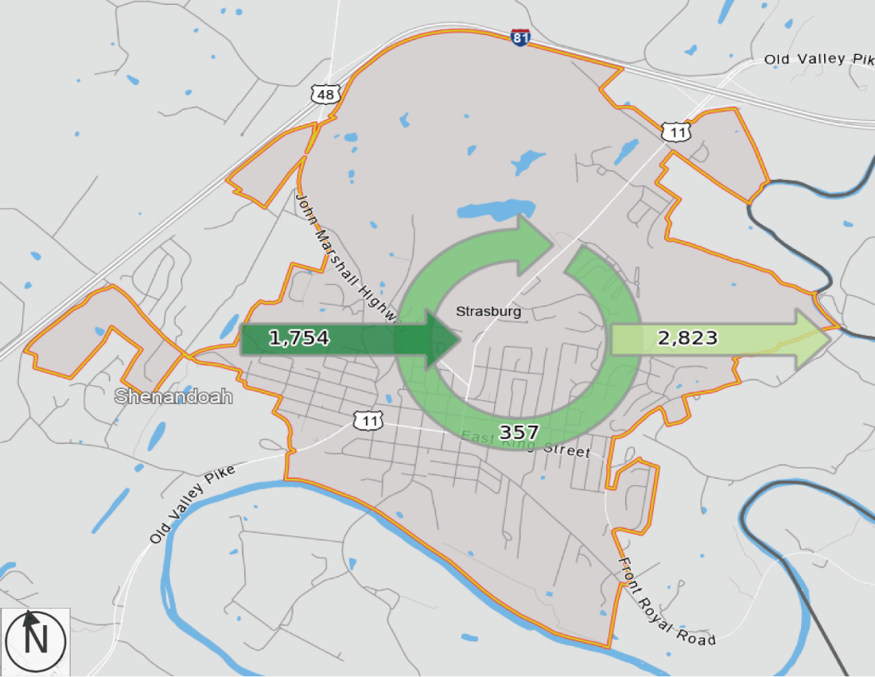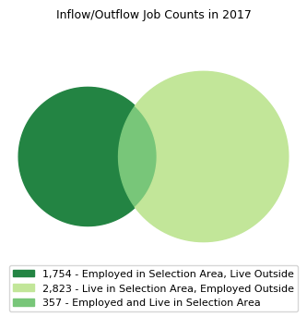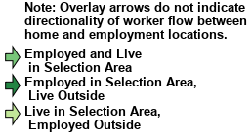

|  |
| --- |
| Source: U.S. Census Bureau, OnTheMap Application and LEHD Origin-Destination Employment Statistics (Beginning of Quarter Employment, 2nd Quarter of 2002-2017). (Data breakdown reflected in tables 16-18) |

Figure 13: Internal Trip Capture

Table 16: Internal Trip Capture, Outflow Characteristics

|  |  |  |
| --- | --- | --- |
| Outflow Job Characteristics (All Jobs) | 2017 | |
| Count | Share |
| External Jobs Filled by Residents | 2,823 | 100.0% |
| Workers Aged 29 or younger | 635 | 22.5% |
| Workers Aged 30 to 54 | 1,592 | 56.4% |
| Workers Aged 55 or older | 596 | 21.1% |
| Workers Earning $1,250 per month or less | 632 | 22.4% |
| Workers Earning $1,251 to $3,333 per month | 952 | 33.7% |
| Workers Earning More than $3,333 per month | 1,239 | 43.9% |
| Workers in the "Goods Producing" Industry Class | 536 | 19.0% |
| Workers in the "Trade, Transportation, and Utilities" Industry Class | 584 | 20.7% |
| Workers in the "All Other Services" Industry Class | 1,703 | 60.3% |

Table 17: Internal Trip Capture, Inflow Characteristics

|  |  |  |
| --- | --- | --- |
| Inflow Job Characteristics (All Jobs) | 2017 | |
| Count | Share |
| Internal Jobs Filled by Outside Workers | 1,754 | 100.0% |
| Workers Aged 29 or younger | 342 | 19.5% |
| Workers Aged 30 to 54 | 907 | 51.7% |
| Workers Aged 55 or older | 505 | 28.8% |
|  |  |  |
| Workers Earning $1,250 per month or less | 343 | 19.6% |
| Workers Earning $1,251 to $3,333 per month | 680 | 38.8% |
| Workers Earning More than $3,333 per month | 731 | 41.7% |
| Workers in the "Goods Producing" Industry Class | 917 | 52.3% |
| Workers in the "Trade, Transportation, and Utilities" Industry Class | 301 | 17.2% |
| Workers in the "All Other Services" Industry Class | 536 | 30.6% |

Table 18: Internal Trip Capture, Interior Characteristics

|  |  |  |
| --- | --- | --- |
| Interior Flow Job Characteristics (All Jobs) | 2017 | |
| Count | Share |
| Internal Jobs Filled by Residents | 357 | 100.0% |
| Workers Aged 29 or younger | 84 | 23.5% |
| Workers Aged 30 to 54 | 173 | 48.5% |
| Workers Aged 55 or older | 100 | 28.0% |
|  |  |  |
| Workers Earning $1,250 per month or less | 100 | 28.0% |
| Workers Earning $1,251 to $3,333 per month | 165 | 46.2% |
| Workers Earning More than $3,333 per month | 92 | 25.8% |
| Workers in the "Goods Producing" Industry Class | 144 | 40.3% |
| Workers in the "Trade, Transportation, and Utilities" Industry Class | 36 | 10.1% |
| Workers in the "All Other Services" Industry Class | 177 | 49.6% |

## Industry Profile

At the end of the second quarter of 2019 there were 2,760 jobs in Strasburg. Manufacturing industry (31-33) employs 45.6% of the total. The industry has grown by 2.9% annually over the last 5 years for a total of 165 new jobs. Over the next 5 years we can expect that growth to slow substantially. The total demand over the next 5 years is projected at 583 including exits and transfers despite the industry decline of .9% annually. The average annual wages in the manufacturing sector are $39,298. Manufacturing in Strasburg has a LQ of 5.52, meaning the concentration of this industry in Strasburg if 5x the national average.

Accommodation and Food Services (72) and Retail Trade are the next largest employment sectors in Strasburg with 252 and 248, respectively. Accommodation and Food Service has the lowest average annual wages of all sectors at $15,582. The LQ for this industry is aligned with the national average. Jobs in this industry declined over the last 5 years, but the sector is projected to experience average annual growth of .7% annually over the next 5 years, for a total demand of 216 jobs. Retail Trade industry concentration is below the national average with a LQ of .86. There was modest .8% average annual industry growth over the last 5 years and is expected to slow to .1% annually over the next 5 years.

Transportation and Warehousing (48) and Public administration (92) round out the top 5 industry sectors in Strasburg. Transportation and Warehousing employs 147, experiencing a spike in growth over the last 5 years which can be attributed to a location event at Northern Shenandoah Industrial Park, and is expected to level out over the next 5 years. Transportation and Warehousing has the highest average annual wages of the top 5 employment sectors at $52,694. Public Administration has a LQ in line with the national average, experiencing growth over the last 5 years, likely a sign of economic recovery from the recession.

Figure 14: Shenandoah River + View of Signal Knob Mountain

Figure 15: Clementine Vintage

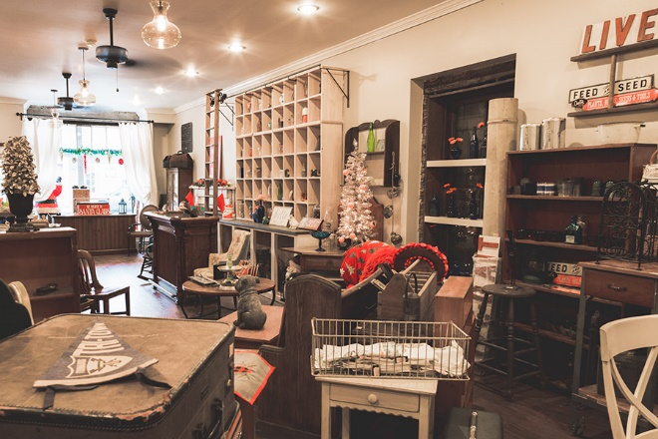

Table 19: Industry Profile, Strasburg

|  |  |  |  |  |  |  |  |  |  |  |  |
| --- | --- | --- | --- | --- | --- | --- | --- | --- | --- | --- | --- |
|  | | Current | | | 5-Year History | | 5-Year Forecast | | | | |
| NAICS | Industry | Empl | Avg Ann Wages | LQ | Empl Change | Ann % | Total Demand | Exits | Transfers | Empl Growth | Ann % Growth |
| 31 | Manufacturing | 1,258 | $39,298 | 5.52 | 165 | 2.9% | 583 | 237 | 404 | -58 | -0.9% |
| 72 | Accommodation and Food Services | 252 | $15,582 | 1.01 | -55 | -3.9% | 216 | 92 | 116 | 9 | 0.7% |
| 44 | Retail Trade | 248 | $25,026 | 0.86 | 10 | 0.8% | 167 | 73 | 92 | 2 | 0.1% |
| 48 | Transportation and Warehousing | 147 | $52,694 | 1.19 | 113 | 33.6% | 83 | 34 | 45 | 4 | 0.5% |
| 92 | Public Administration | 136 | $41,634 | 1.05 | 46 | 8.6% | 66 | 27 | 36 | 3 | 0.4% |
| 62 | Health Care and Social Assistance | 131 | $37,914 | 0.33 | 7 | 1.1% | 83 | 32 | 33 | 17 | 2.5% |
| 52 | Finance and Insurance | 95 | $52,992 | 0.87 | -15 | -2.9% | 45 | 17 | 28 | 0 | 0.0% |
| 81 | Other Services (except Public Administration) | 93 | $24,107 | 0.77 | 18 | 4.3% | 55 | 24 | 29 | 2 | 0.5% |
| 56 | Administrative and Support and Waste Management and Remediation Services | 92 | $32,575 | 0.52 | -298 | -25.1% | 59 | 23 | 31 | 5 | 1.0% |
| 51 | Information | 72 | $60,916 | 1.34 | 39 | 16.6% | 30 | 12 | 22 | -4 | -1.3% |
| 61 | Educational Services | 63 | $32,236 | 0.28 | -26 | -6.7% | 31 | 14 | 15 | 1 | 0.4% |
| 53 | Real Estate and Rental and Leasing | 37 | $30,468 | 0.79 | 4 | 2.5% | 20 | 9 | 10 | 1 | 0.5% |
| 23 | Construction | 34 | $37,837 | 0.21 | -4 | -2.2% | 19 | 6 | 11 | 2 | 1.1% |
| 54 | Professional, Scientific, and Technical Services | 33 | $62,574 | 0.18 | -5 | -3.0% | 15 | 5 | 9 | 1 | 0.7% |
| 11 | Agriculture, Forestry, Fishing and Hunting | 25 | $27,911 | 0.68 | -1 | -1.1% | 15 | 6 | 8 | 1 | 0.7% |
| 71 | Arts, Entertainment, and Recreation | 17 | $17,835 | 0.31 | -4 | -4.0% | 13 | 5 | 7 | 1 | 0.8% |
| 42 | Wholesale Trade | 16 | $42,102 | 0.15 | -2 | -2.0% | 8 | 3 | 5 | 0 | -0.6% |
| 55 | Management of Companies and Enterprises | 8 | $206,631 | 0.19 | -5 | -9.4% | 4 | 1 | 2 | 0 | 0.6% |
| 99 | Unclassified | 4 | $29,108 | 1.32 | 4 | n/a | 2 | 1 | 1 | 0 | 0.4% |
|  | **Total - All Industries** | **2,760** | **$37,732** | **1.00** | **-10** | **-0.1%** | **1,491** | **644** | **859** | **-11** | **-0.1%** |

Source: JobsEQ  
Industry and Occupation Data as of 2019Q2  
1. All data based upon a four-quarter moving average  
Exits and Transfers are approximate estimates based upon occupation separation rates

## Occupation Profile

Table 20: Occupation Profile, Strasburg

|  | | **Current** | | | | | | **5-Year History** | | **5-Year Forecast** | | | |
| --- | --- | --- | --- | --- | --- | --- | --- | --- | --- | --- | --- | --- | --- |
| SOC | Occupation | Empl | Avg Ann Wages2 | LQ | Unempl | Unempl Rate | Empl Change | Ann % | Total Demand | Exits | Transfers | Empl Growth | Ann % Growth |
| **51** | **Production** | 723 | $38,900 | 4.36 | 7 | 2.2% | 20 | 0.6% | 356 | 145 | 245 | -35 | -1.0% |
| **43** | **Office and Administrative Support** | 352 | $34,200 | 0.89 | 10 | 2.0% | -19 | -1.0% | 174 | 85 | 103 | -14 | -0.8% |
| **53** | **Transportation and Material Moving** | 290 | $31,700 | 1.52 | 7 | 2.7% | 8 | 0.6% | 175 | 70 | 105 | -1 | 0.0% |
| **41** | **Sales and Related** | 232 | $42,100 | 0.84 | 7 | 3.1% | -5 | -0.4% | 162 | 71 | 90 | 1 | 0.1% |
| **35** | **Food Preparation and Serving Related** | 228 | $21,800 | 0.96 | 8 | 3.4% | -41 | -3.3% | 212 | 90 | 112 | 11 | 0.9% |
| **11** | **Management** | 139 | $91,400 | 0.82 | 1 | 0.9% | 11 | 1.7% | 55 | 21 | 32 | 2 | 0.2% |
| **49** | **Installation, Maintenance, and Repair** | 133 | $43,200 | 1.26 | 2 | 1.4% | 27 | 4.6% | 62 | 24 | 39 | 0 | 0.0% |
| **13** | **Business and Financial Operations** | 106 | $69,800 | 0.73 | 1 | 1.6% | 1 | 0.3% | 47 | 15 | 31 | 1 | 0.1% |
| **37** | **Building and Grounds Cleaning and Maintenance** | 91 | $26,500 | 0.96 | 2 | 3.0% | -7 | -1.5% | 61 | 27 | 30 | 3 | 0.7% |
| **39** | **Personal Care and Service** | 79 | $23,300 | 0.65 | 3 | 2.5% | 6 | 1.5% | 69 | 32 | 30 | 8 | 1.9% |
| **25** | **Education, Training, and Library** | 52 | $43,100 | 0.34 | 2 | 1.8% | -20 | -6.3% | 25 | 12 | 11 | 2 | 0.6% |
| **33** | **Protective Service** | 48 | $44,900 | 0.80 | 1 | 1.4% | 13 | 6.8% | 23 | 10 | 12 | 1 | 0.5% |
| **47** | **Construction and Extraction** | 47 | $41,700 | 0.36 | 3 | 2.9% | -8 | -3.0% | 25 | 9 | 15 | 1 | 0.5% |
| **29** | **Healthcare Practitioners and Technical** | 46 | $66,700 | 0.29 | 1 | 0.9% | -3 | -1.4% | 17 | 7 | 7 | 3 | 1.4% |
| **15** | **Computer and Mathematical** | 45 | $73,500 | 0.55 | 0 | n/a | 2 | 0.8% | 15 | 4 | 11 | 0 | 0.1% |
| **27** | **Arts, Design, Entertainment, Sports, and Media** | 43 | $52,800 | 0.89 | 0 | n/a | 1 | 0.5% | 18 | 8 | 11 | -2 | -0.8% |
| **17** | **Architecture and Engineering** | 34 | $76,700 | 0.73 | 0 | n/a | 6 | 4.1% | 12 | 4 | 8 | 0 | -0.1% |
| **31** | **Healthcare Support** | 30 | $26,400 | 0.40 | 2 | 1.8% | -7 | -4.3% | 22 | 10 | 9 | 4 | 2.3% |
| **21** | **Community and Social Service** | 19 | $41,100 | 0.41 | 0 | n/a | 5 | 5.9% | 12 | 4 | 7 | 1 | 1.3% |
| **19** | **Life, Physical, and Social Science** | 9 | $61,000 | 0.40 | 0 | n/a | 1 | 3.5% | 4 | 1 | 3 | 0 | 0.4% |
| **23** | **Legal** | 9 | $80,400 | 0.37 | 0 | n/a | -1 | -1.4% | 3 | 1 | 1 | 0 | 0.8% |
| **45** | **Farming, Fishing, and Forestry** | 6 | $28,300 | 0.33 | 0 | n/a | 0 | -0.4% | 4 | 1 | 3 | 0 | -0.1% |
|  | **Total - All Occupations** | **2,760** | **$41,600** | **1.00** | **58** | **2.2%** | **-10** | **-0.1%** | **1,555** | **652** | **914** | **-11** | **-0.1%** |

Source: JobsEQ  
Industry and Occupation Data as of 2019Q2  
1. All data based upon a four-quarter moving average  
Exits and Transfers are approximate estimates based upon occupation separation rates

## Connectivity

### Internet Infrastructure

Shentel is the sole provider of residential internet in Strasburg and offers a cable connection on King Street with available speeds of 50-300MBps download and 10MBps upload. Pricing ranges from $65-200/month for internet alone. Recently, Shentel began to offer triple play packages bundling internet, telephone, and cable. Triple Play options range from $173-$226 per month with various levels of service. One other cable provider serves Strasburg, Direct TV. HughesNet is another available option for internet access. HughesNet is a data-based plan with max download speed of 25MBps and upload of 3MBps. Hughesnet uses satellite technology to deliver internet to the home. New additions include: LiveStream (VA Air) and Fox Wireless.

### Road Network

Route 11 onto North Massanutten Street remains the most highly travelled corridor in Town limits with between 6,700 and 13,000 vehicles traveling daily. This traffic diverges onto 55 or King Street which each handle 2,800-6,700 vehicles daily. The next most traveled roads are Ash St., Washington St., Powhatan St., Queen St., Sandy Hook, and Caron St, all with 960-2,800 vehicles travelling daily. A Traffic Count Map can be found in Appendix F.

## Real Estate

Below is a list of commercial and retail properties for sale within the Strasburg Town Limits. These properties were listed on either LoopNet or on the Old Dominion Realty Commercial Listings webpage.

|  |
| --- |
| **263 West King Street, Units 241, 247, 25** |
| * Commercial Building * 7 Bay Garage, 3 Apartments * Not Vacant * Built in 1907. * .46 Acres * $1,500,000 |

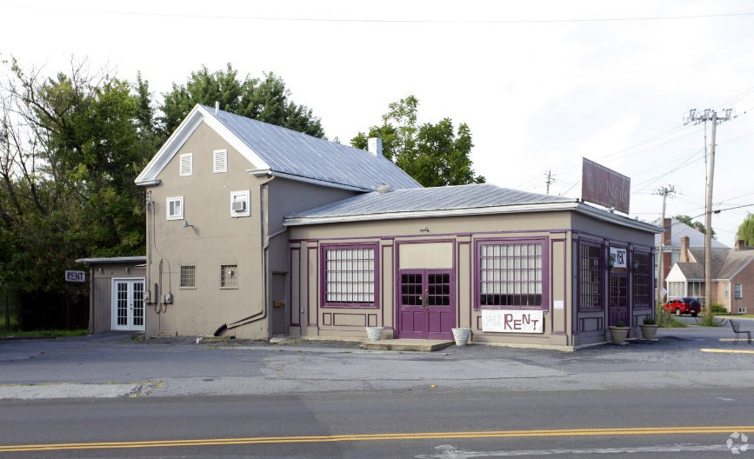

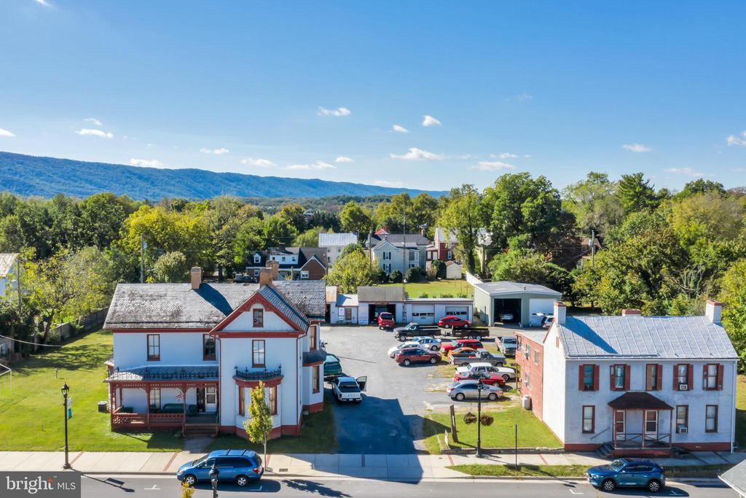

|  |
| --- |
| **318 East King Street** |
| * 3,138 SF Retail Building * Vacant * 2 Stories * Built in 1945 * Class C * .29 Acres * $399,000 |

|  |
| --- |
| **327 North Massanutten Street** |
| * 14,120 SF Retail Building * Vacant * 2 Stories * Built in 1942 * Class C * $820,459 |

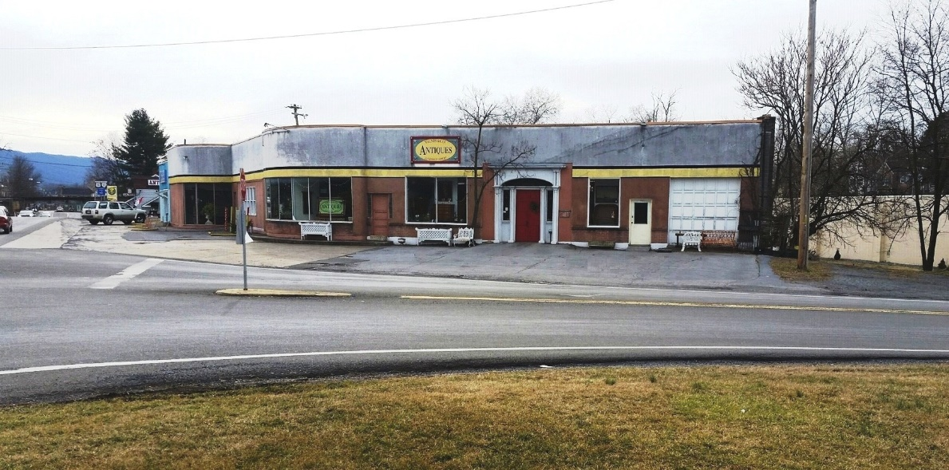

|  |
| --- |
| **0 Oxbow Drive** |
| * Commercial Land * Located Near Interstate * .95 Acres * $450,000 |

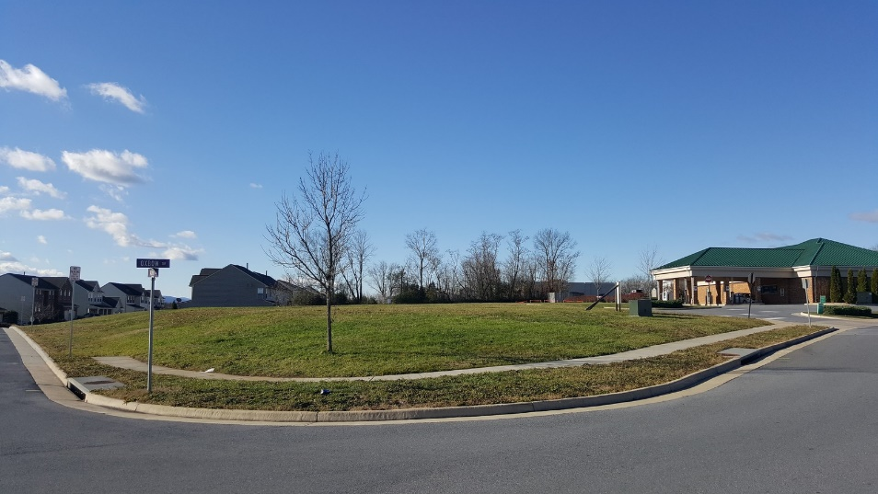

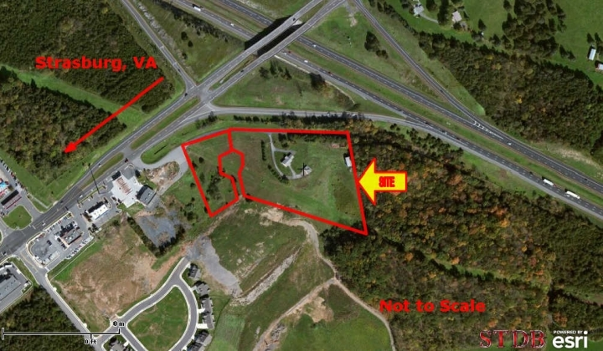

|  |
| --- |
| **144 Fort Bowman Road** |
| * Commercial Land * 2 Properties * Located Near Interstate * 4.64 Acres * $425,000 |

# Appendix D: Retail Analysis

The retail market analysis was completed on secondary research, with the understanding that additional primary research will be completed through a questionnaire to be distributed in participation with the Master Park Plan.

## Retail Leakage Report

There are four comparison localities, all located in Virginia and south of Strasburg. They were chosen for their population, proximity to I-81, and proximity to the Shenandoah River. The comparison localities are: Town of Bridgewater, Buena Vista City, Lexington City, and the Town of Woodstock. All The following retail information is as of 2017, generated by Esri.

Within these broad retail categories, significant opportunities exist in the following areas:

|  |  |
| --- | --- |
| * Automobile dealers * Furniture store * Home furnishings stores * Building material suppliers * Lawn and garden stores * Specialty food stores * Clothing stores * Shoe stores * Jewelry stores * Sports, hobby, musical instrument stores * Book stores and news stands | * Department stores * General merchandise stores * Office supply and gift stores * Other miscellaneous retailers * E-shopping and mail-order houses * Vending machine operators * Direct selling establishments * Special food services * Drinking places- alcohol * Restaurants/other eating places |

Retail sales are strongest in the board categories of gasoline stations, automobile parts and dealers, and electronics and appliances drawing sales from outside of Strasburg. Detailed retail categories contributing a surplus of retail sales are:

|  |  |
| --- | --- |
| * Auto parts, accessories, and tire stores * Electronics stores * Grocery stores * Beer/wine/liquor stores | * Gasoline stations * Florists * Used merchandise stores |

Table 21: Retail Leakage by Locality

|  |  |  |  |  |  |
| --- | --- | --- | --- | --- | --- |
| Broad Retail Categories | Town of Strasburg | Town of Bridgewater | City of Buena Vista | City of Lexington | Town of Woodstock |
| 2017 Leakage/Surplus Factor: Total Retail | 6.3 | 20.6 | 17.9 | -25.4 | -43.9 |
| 2017 Total Retail Businesses | 50 | 39 | 40 | 104 | 100 |
| 2017 Leakage/Surplus Factor: Motor Vehicle and Parts Dealers | -23.4 | 88.1 | 75.0 | 58.1 | -34.8 |
| 2017 Businesses: Motor Vehicle and Parts Dealers | 7 | 2 | 3 | 5 | 8 |
| 2017 Leakage/Surplus Factor: Furniture/Home Furnishing Stores | 100.0 | 78.2 | 100.0 | -51.6 | 13.3 |
| 2017 Businesses: Furniture/Home Furnishing Stores | 0 | 1 | 0 | 5 | 2 |
| 2017 Leakage/Surplus Factor: Electronics & Appliance Stores | -17.7 | 29.3 | 100.0 | -1.4 | 6.8 |
| 2017 Businesses: Electronics & Appliance Stores | 2 | 1 | 0 | 2 | 3 |
| 2017 Leakage/Surplus Factor: Bldg./Garden Equip/Supply Stores | 47.8 | 56.6 | 26.2 | 8.9 | -59.7 |
| 2017 Businesses: Bldg./Garden Equip/Supply Stores | 2 | 2 | 3 | 4 | 6 |
| 2017 Leakage/Surplus Factor: Health & Personal Care Stores | 4.4 | 49.6 | -18.5 | -62.0 | -32.7 |
| 2017 Businesses: Health & Personal Care Stores | 3 | 1 | 2 | 8 | 8 |
| 2017 Leakage/Surplus Factor: Gasoline Stations | -20.5 | -3.9 | -6.0 | -11.2 | -59.2 |
| 2017 Businesses: Gasoline Stations | 1 | 1 | 3 | 2 | 4 |
| 2017 Leakage/Surplus Factor: Clothing/Accessories Stores | 87.8 | 100.0 | 58.3 | -0.5 | 30.3 |
| 2017 Businesses: Clothing/Accessories Stores | 1 | 0 | 3 | 7 | 4 |
| 2017 Leakage/Surplus Factor: Sports/Hobby/Book/Music Stores | 81.2 | -17.5 | -16.7 | -11.5 | 14.7 |
| 2017 Businesses: Sports/Hobby/Book/Music Stores | 2 | 2 | 2 | 7 | 2 |
| 2017 Leakage/Surplus Factor: General Merchandise Stores | 85.7 | -22.8 | 69.8 | 65.3 | -65.7 |
| 2017 Businesses: General Merchandise Stores | 1 | 3 | 2 | 2 | 4 |
| 2017 Leakage/Surplus Factor: Miscellaneous Store Retailers | 24.6 | 43.7 | -5.6 | -48.1 | -13.1 |
| 2017 Businesses: Miscellaneous Store Retailers | 10 | 5 | 4 | 21 | 17 |
| 2017 Leakage/Surplus Factor: Nonstore Retailers | 100.0 | 42.4 | -38.1 | 100.0 | 100.0 |
| 2017 Businesses: Nonstore Retailers | 0 | 1 | 1 | 0 | 0 |
| 2017 Leakage/Surplus Factor: Food Services & Drinking Places | 7.0 | 6.2 | 28.5 | -51.5 | -49.5 |
| 2017 Businesses: Food Services & Drinking Places | 16 | 18 | 12 | 33 | 34 |

## Tapestry Segmentation

Tapestry Segments are a data point provided by ESRI based on demographics and socioeconomic characteristics. Tapestry Segmentation classifies neighborhoods onto 67 unique segments, providing insight that aids in identifying best customers, optimal sites, and underserved markets. These unique segments help potential investors understand customers’ lifestyle choices, what they buy, and how they spend their free time. This analysis can assist in the wise investment of resources to provide goods and services to a community[1].

Tapestry segmentation represents a 3-mile radius from the town’s center.

Table 22: Tapestry Segment Distribution

|  |  |  |
| --- | --- | --- |
| Top 5 Tapestry Segments | | |
| 1 | Middleburg | 41.0% |
| 2 | Heartland Communities | 26.0% |
| 3 | Front Porches | 18.7% |
| 4 | Green Acres | 14.3% |
| 5 | Salt of the Earth | 0.1% |
|  | Total | 100.1% |

**Middleburg:**

* Average Household Size: 2.75
* Median Age: 36.1
* Median Household Income: $59,800
* Prefer to buy American made products, including cars
* Neighborhoods characterized by affordable housing, with a median value of $175,000, Middleburg segment spends 11% less than the US average on housing
* Labor force participation is high (66.7%), unemployment is low (4.7%)
* Spending on entertainment and recreation is just 2% below the national average, and trends towards family friendly activities, hunting, fishing, bowling, and baseball.
* Spending priorities are typically children and DIY projects
* Drive trucks and SUVs

**Heartland Communities:**

* Average Household Size: 2.39
* Median Age: 42.3
* Median Household Income: $42,400
* Residents own modest single-family homes built before 1970 with a median value of $95.700
* Prefer to buy American made products and stick to the brands they grew up with
* Labor force participation (60%) and household size are impacted by retirement and aging
* Budget savvy and spend far less than the US average in all categories except for pensions and social security
* Residents participate in public activities to support their community
* Hobbies include motorcycling, hunting, fishing; walking is the main form of exercise
* Drive trucks and SUVs

**Front Porches:**

* Average household size: 2.57
* Median Age 34.9
* Median Household Income: $43,700
* 53.4% of this segment nationwide rents with an average payment of $913, half are older single-family dwellings and one in five is a duplex, triplex, or quad
* Blue collar workers with high labor force participation, and higher unemployment at 7.1%
* Segment is characterized by single parent families or singles living alone
* Seek adventure and strive to have fun, activities include sports, board games, video games, and enjoy most forms of entertainment from their mobile phones

**Green Acres:**

* Average Household Size: 2.70
* Median Age: 43.9
* Median Household Income: $76,800
* Primarily older homes with acreage with a median home value of $235,000
* Enjoy hunting, fishing, motorcycling, camping, and golf
* Cautious consumers with a focus on quality and spend at or above the national average in all categories
* Primarily married couples with no children
* DIYers with gardens, and are active in the community
* Drive trucks and SUVs

**Salt of the Earth:**

* Average Household Size: 2.59
* Median Age: 44.1
* Median Household Income: $56,300
* 83% of this segment owns a single-family home with a median home value of $154,300
* Prefer to buy American and are cost-conscious
* Typically, married couples, less than half have children at home
* Employment characterized by construction, manufacturing, and related service industries
* Try to eat healthy, care about ingredients and nutrition
* DIYers with gardens
* Drive trucks and typically have two cars to cover long commutes

# Appendix E: Discover 2025 Action Plan

Table 23: Discover 2025 Action Plan Spreadsheet



# Appendix F: Maps

Figure 16: Population Density Map, Strasburg

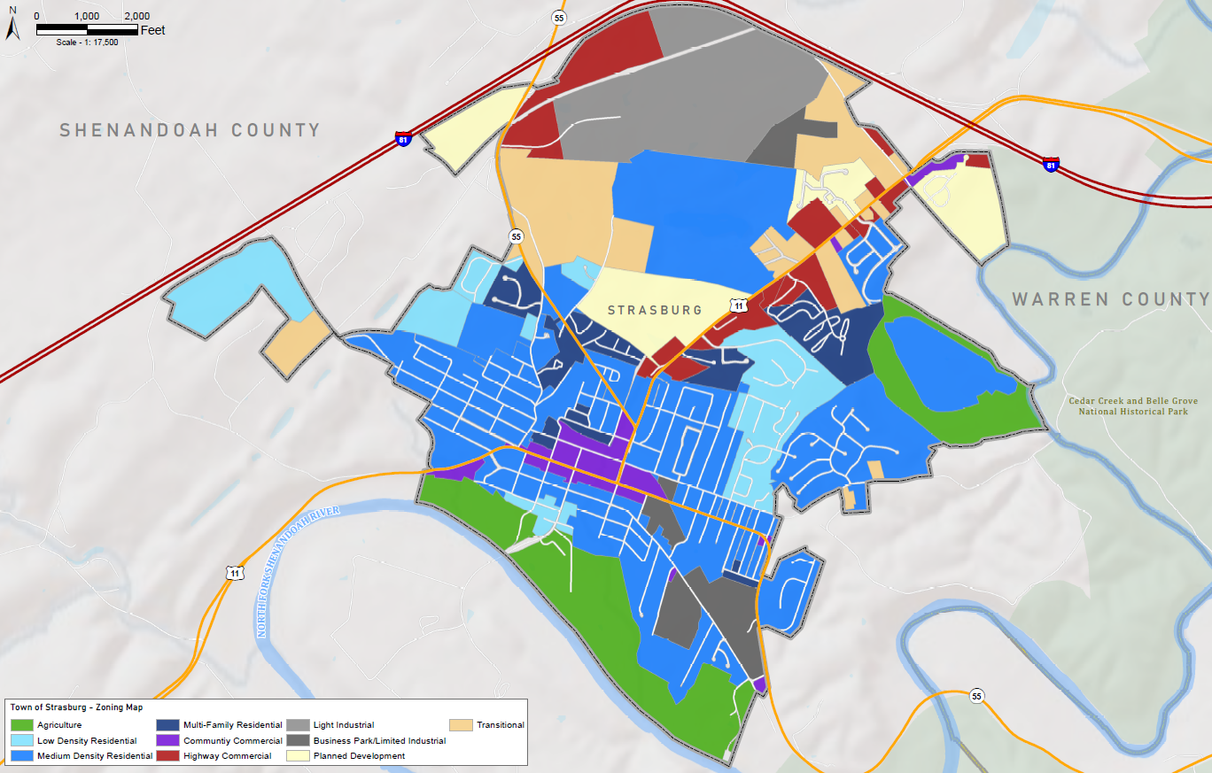

Figure 17: Zoning Map, Strasburg

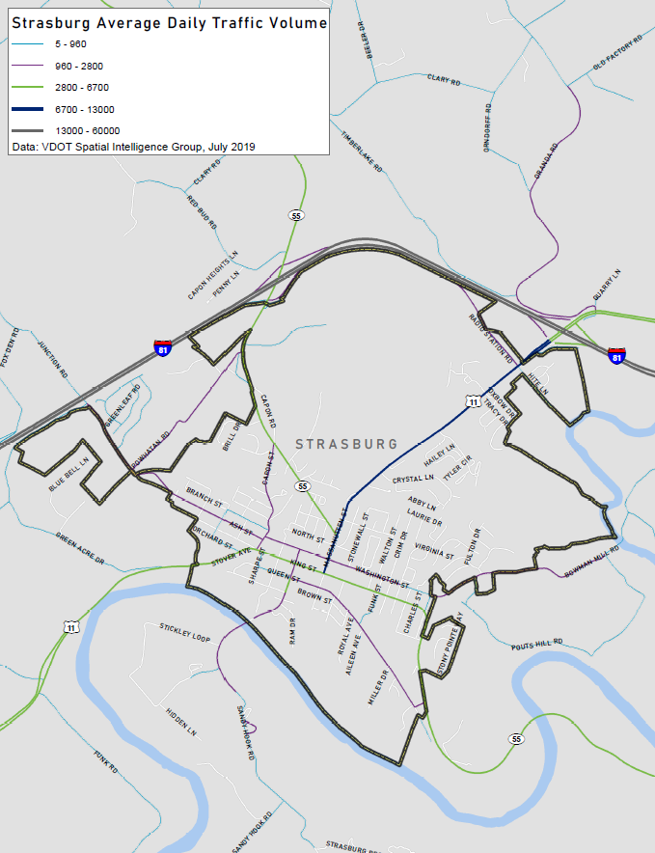

Figure 18: Daily Traffic Volume Map

1. https://www.esri.com/en-us/arcgis/products/tapestry-segmentation/overview