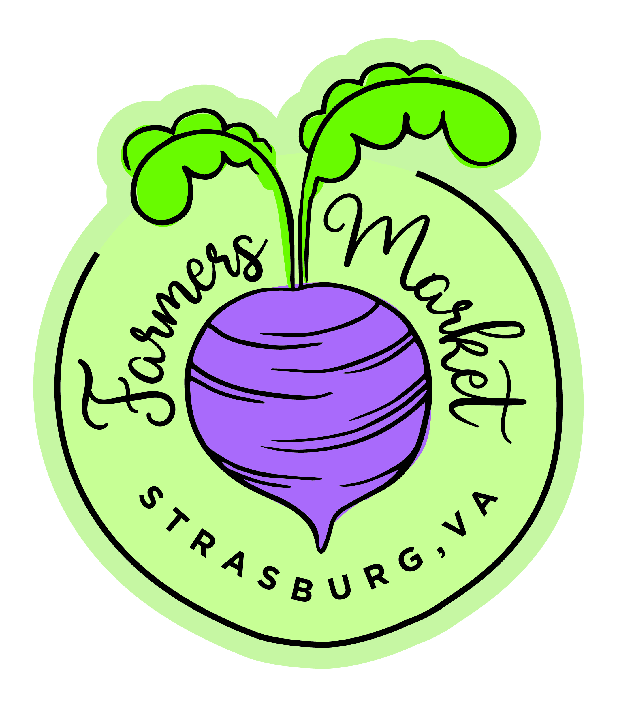
Strasburg Farmers Market 2023

Mission:
The mission of the Strasburg Farmers Market is to provide a place in downtown Strasburg for people to purchase locally grown, fresh, healthy produce and products. The market encourages, supports, and promotes the entrepreneurial efforts of local, independent and small-scale farmers, local growers and artisans to sell their products directly to consumers. The market strives to create an environment that serves the market vendors and customers, and contributes to our rural community.

Market Manager: Allyson Thomas: strasburgfarmersmarket@gmail.com
Town of Strasburg contact: Brian McKee bmckee@strasburgva.com
Strasburg Farmers Market Committee

Structure:
- Guidelines for Market Products:
We are 100% producer only. We are 100% Virginia Grown. Any exceptions will be reviewed on a case-by-case basis.

Vendor registration priority will be given to farm products (meats, vegetables, plants, etc), and then to artisan craft items (soaps, pottery, etc).

Example products include, but not limited to, producers of fresh vegetables and fruits, fresh or dried flowers, wreaths, home-basked goods, herb vinegars, cider, properly labeled home processed preserves, jams, jellies, pickles, relishes, chutneys, soups, dips, sauces, fermented foods, teas, salves, soap, herbal remedies, and artisan craft objects.

The aim of the market is to meet the expectations of the customers with the appropriate mix of products suitable for the market, determined by the market manager and committee.

- Membership:
Membership is open by application to Virginia residents within a 50-mile radius of Strasburg, Virginia. Others are reviewed by the committee on a case-by-case basis. Any person wishing to participate as a vendor must apply for review for approval. Occasional vendors may be allowed to participate for special events or fundraising at the Market Manager’s discretion.
- Location:
The Strasburg Farmers Market will be held at the Strasburg Square and Market Pavilion, 216 East King Street, on the FIRST and LAST Saturday mornings April through October, from 9am to 1pm. Participation during inclement weather is left to the discretion of the market manager.

- Market Manager:
The Market Manager will oversee all activities of the Market. They will be assisted by the SFM committee.

- Market Members:
The market members are responsible for complying with all federal, state and local laws including the collection of appropriate taxes.

- Product Liability Insurance:
It is highly recommended that each vendor obtain product liability insurance ($1M), with an option of naming SFM as an additional insured. The Strasburg Farmers Market is not responsible for any loss or damage incurred by vendors. Vendors are liable for the safety of their own products.
- Strasburg Farmers Market Committee:
The committee’s purpose is to advise the Market Manager on topics such as advertising, applications, vendor positions, and possible partnerships with the Town of Strasburg, Shenandoah County and any interested organizations.
- Dues:
Dues are to be paid before the vendor sets up for their first market. Vendor fees are as follows: $50 for full time and $5 for a one time drop in. These fees are subject to change each year. The Market Manager and the Town of Strasburg will collect fees and maintain the market budget. Dues and fees will be spent solely on advertising, use of the space, location insurance, and other appropriate non-profit needs.
- Conduct:
SFM participants judged to be disruptive or detrimental to the peaceful operation of the market will not be allowed.
- Market Space and Setup
Vendors will sell from their designated spaces determined at the beginning of the market season. All tents, signage and display racks must be within the assigned space and securely anchored. The Market Manager will provide space maps for each season. Vendors must be set up by 8:45am on market days. An absentee notification to the market manager is required at least 24 hours in advance.

