Chapter 84 – ZONING ORDINANCE
ARTICLE VIII. – HISTORIC DISTRICTS AND OVERLAYS
PART 800. – HISTORIC DISTRICT
Sec. 84-800.01. – Purpose.
The intent of these districts is to protect and preserve the old and historic structures and individual landmarks located within those districts. Historic preservation is an evolving process that seeks to balance the public mission of historic preservation with the private property rights of individual owners.
It is the purpose of Part 800 to retain the distinct and treasured physical imprint of Strasburg's unique architectural styles, building types and forms, streetscapes and neighborhoods in the historic districts as they survive subsequent generations of development. Additionally, Part 800 and 801 are intended to serve the public interest and to promote the public welfare by:
- Carrying out the goals of the Comprehensive Plan to preserve the historic districts and individual landmarks, not only for their own value as community resources, but also because of their contributions to the Town's unique character;
- Promoting the identification, recognition, preservation, and enhancement of buildings, structures, and neighborhoods that have special historical, cultural, social, economic, political, artistic, architectural, or archaeological significance as provided by Code of Virginia, § 15.2-2306, as amended;
- Retaining the basis of our heritage and foster pride in the Town's past by educating residents and visitors on local cultural and historic heritage;
- Increasing property values by encouraging the preservation and rehabilitation of significant historic buildings and structures, and by maintaining the historic integrity of streetscapes and neighborhoods;
- Maintaining an archival record of properties within the historic districts;
- Preserving and enhancing the Town's historic attractions for tourists and visitors, thereby supporting and stimulating business and industry, and strengthening the Town's economy; and
- Enacting the regulations required to establish conditions for public and private grants and other similar funding opportunities which assist with the preservation of structures within the historic districts.
Sec. 84-800.02. – General.
This Part shall apply to the R-H and B-H district identified and to other areas or places that may be designated by the Town Council as historic districts or landmarks.
Sec. 84-800.03. – District boundaries.
- All historic district boundaries shall be designated on the official zoning map of the Town of Strasburg. Any property partially located within the historic district boundaries shall be considered to be fully located within the historic district.
- Modification of the boundaries shall comply with the following.
- Expansion. Historic Districts may be enlarged and new historic districts and individual landmarks may be established pursuant to Code of Virginia, § 15.2-2306, as amended, upon the recommendation of the ARB and adoption by the Town Council. The Council may include property into new or existing historic districts with or without the consent of the property owner. In modifying existing or creating new Historic Districts, the boundaries of such shall be clearly delineated using the services of a professional land surveyor or identification by tax parcel number(s).
- Application for Designation. Applications for designation shall be considered by the Town Council upon recommendation of the ARB. Application shall be made to the Board by the owner of the property to be designated or by any organization with a recognized interest in historic preservation. The Town Council may institute a voluntary plaque program for designated historic properties.
- Existing zoning not affected. The regulation of a Historic District shall be in addition to the regulations of the underlying zoning, and shall be applied so as to overlay and be superimposed on such other zoning districts as permitted by the provisions of this Chapter and shown on the official zoning map. Any property lying within a Historic District shall also lie within one or more of such other zoning district which shall be known as underlying districts.
- If the Architectural Review Board has voted to recommend designation of an area as an Historic Overlay District, the demolition or destruction of any building, site, or structure located in the proposed district or on the property of the proposed historic landmark may be delayed by the Board for a period of up to 180 days or until the Town Council takes final action on the designation, whichever occurs first. Should the Council approve the designation prior to the expiration of the 180-day delay period, an application for a certificate of appropriateness for demolition shall then be requested.

Sec. 84-800.04. – Maintenance of historic properties.
- Ordinary Maintenance Exclusion: Normal Repair and Routine Maintenance. Normal repair and routine maintenance as defined by Article I shall be exempt from review by the Architectural Review Board. Repair and maintenance should retain existing materials and features while employing as little new material as possible. Such repair begins with the least degree of intervention possible by strengthening fragile materials through consolidation, patching, limited splicing in kind or otherwise reinforcing using recognized preservation methods. All work should be physically and visually compatible. The replacement material should match the old both physically and visually, i.e., wood for wood, slate for slate. The following constitute normal repair and/or routine maintenance:
- Painting or repainting the same or a different color. Original painting of masonry surfaces is considered a major modification and is not exempted from review.
- Work done to prevent deterioration or to replace parts of a structure with similar materials in order to correct any deterioration, decay of, or damage to any structure or on any part thereof.
- Landscaping activities including planting of grass, trees or shrubs, grading, walks, retaining walls, fencing, and the like.
- Minimum Maintenance Requirement: Demolition by Neglect.
- No building or structure within any Historic District shall be allowed to deteriorate from purposeful neglect or action to the extent that decay or deterioration may, in the opinion of the ARB, result in its significant loss of character or integrity, create a serious life safety or structural stability situation, or have an adverse effect upon the character and integrity of the district. If the Board should make such a finding, it shall request a report of the Zoning Administrator who shall report to the ARB on the following matters which may exist:
- Deterioration of exterior walls or other vertical supports;
- Deterioration of roofs or other horizontal members;
- Deterioration of any part of the structure due to missing windows, doors, or other openings;
- Deterioration of chimneys;
- Deterioration or crumbling of exterior stucco or mortar;
- Prolonged water penetration, rotting, and other forms of decay;
- The lack of maintenance of the surrounding environment causing deterioration to the building or structure through poorly maintained landscaping or plant overgrowth including overhanging trees, limbs or roots allowed to beat against or grow into the resource; or invasive vines such as climbing ivy with tendrils that attach to and cause loss of mortar and structural soundness in masonry walls and pull out corner boards, weatherboard and other wooden elements causing an unsafe condition;
- Deterioration of any building or structure so as to create, or permit the creation of any hazardous or unsafe condition; and
- Determination by the Zoning Administrator or designee that a structure is unsafe or not in compliance with any safety provisions of the statewide building code.
- The ARB shall hold a public hearing on the report prior to making a determination about any violation of this section. The Zoning Administrator shall notify the owner of the subject property of the hearing and provide the owner with a copy of the report. The owner shall have 30 days from the decision to appeal to the Town Council a determination by the ARB of a violation of this section.
- The owner shall have 60 days from the date of the ARB's determination to present to the ARB a plan to remedy the neglect and six months from the ARB's approval of the plan to complete the necessary remedial work. If the owner appeals the determination of the ARB within the time period prescribed above, the deadlines to present a plan and complete the remedial work shall not begin until the Town Council takes action. If appropriate action is not taken by the owner, the Zoning Administrator shall initiate appropriate legal action for a violation of this Chapter.
- Public Safety Exclusion. Nothing in this Chapter shall prevent the razing or demolition of any building or structure without consideration of the ARB, which is in such an unsafe condition that it would imminently endanger life or property, and protection from such condition is provided for in the statewide building code and/or other applicable ordinances. However, such razing or demolition shall not be commenced without written approval of the Zoning Administrator and Zoning Administrator verifying the conditions necessitating such action.
Sec. 84-800.05. – Types of improvements
- Minor Modifications. Minor modifications do not require ARB review and recommendation. For minor modifications, no application for a Certificate of Appropriateness is required. The following constitute a minor modification:
- Replacement or reconstruction of architectural features (shutters, trim, gutters, siding, roofing, porches, windows, etc.) using similar materials;
- Addition or deletion of storm doors or storm windows and window gardens, or similar appurtenances;
- Addition or deletion of television and radio antennas; or skylights and solar collectors, except on the primary façade;
- Construction of off-street loading or parking areas containing three spaces or less;
- Replacement of missing or broken window panes, roofing slates, tiles, or shingles, and outside doors, window frames, or shutters where no substantial change in design or material is proposed; and
- Any similar action which in the written determination of the Zoning Administrator will have no more effect on the character of the district than those activities listed above.
- Major Modification. Major modifications do require ARB review and recommendation. Application for a Certificate of Appropriateness is not required for a major modification. Major modifications are deemed to have a permanent effect upon the character of the Historic District, and include, but are not limited to, the following:
- Application of a substitute siding material over wood siding;
- Installation of replacement windows of a substitute material;
- Addition or deletion of a window or door opening;
- Original painting of a masonry surface;
- Any change or alteration of the exterior architectural style of a structure, including removal or rebuilding of porches, opening, dormers, window sash, chimneys, columns, structural elements, stairways, terraces, and the like;
- Addition or removal of one or more stories or alteration of a roof line;
- All signs;
- Addition or deletion of awnings, canopies, and similar appurtenances;
- Any other major actions not specifically covered by the terms of this section but which, in the written determination of the Zoning Administrator, would have a substantial effect on the character of the historic district.
- Tax Credit Requires Certificate of Appropriateness. If the owner is seeking a real estate tax exemption, the ARB shall take action on the application and either approve, disapprove, or approve with conditions. If the proposal is approved, the Board shall issue a Certificate of Appropriateness which indicates the approved modifications and any conditions of approval. If the application is disapproved, the Board shall indicate in writing, the reasons for such action and suggest conditions under which the application may be approved. Failure by the Board to issue a certificate of appropriateness shall disqualify an owner from receiving the tax exemption benefits. The ARB Board shall review the proposal for compliance with the review criteria provided in this Chapter and shall make recommendations to the owner. If the proposal is approved, the Board shall issue a Certificate of Appropriateness which indicates the approved modifications and any conditions of approval. If the application is disapproved, the Board shall indicate in writing, the reasons for such action and suggest conditions under which the application may be approved. Failure by the Board to issue a certificate of appropriateness shall disqualify an owner from receiving the tax exemption benefits.
- Improvements that Require Certificate of Appropriateness. The following improvements also require ARB review and recommendation.
- Demolition;
- New construction, addition, movement, or relocation. Construction of a new building, new accessory building, an addition which increases the square footage of the building, or the movement or relocation of an existing structure. This includes any addition to or alteration of a building which increases the square footage of the building or otherwise alters substantially its size, height, contour, or outline; and
- Reconstruction over 50%
Sec. 84-800.07. – Signage in historic districts.
All signage within a historic district shall comply with the standards set for in Part 306 of this Chapter.
Sec. 84-800.08. – Certificate of Appropriateness.
The application and review requirements for the Certificate of Appropriateness shall comply with the Administrative Procedures Manual.
Sec. 84-800.09. – Short-term Rentals and Homestays.
- Registration.
  - Prior to operation, the operator of any homestay or short-term rental shall
    - Register the property with the Department of Planning and Zoning, unless exempt from registration pursuant to Section 15.2-983(B)(2) of the Code of Virginia, as amended. Registration shall be valid from the date the registration occurs through December 31 and shall be renewed annually by March 1.
    - As a part of the registration and annual renewal, a rental inspection report from the Shenandoah County Building Official shall be provided.
    - Obtain a business license. The business license shall be valid from the date the registration occurs through December 31 and shall be renewed annually by March 1.
  - Each registration shall be specific to the operator and property and is nontransferable.
  - Short-term rental uses legally establish prior to July 1, 2024:
    - Shall be permitted to operate under the zoning text amendment adopted October 12, 2021.
    - The annual renewal as stated within this section shall apply.
    - If the use ceases for a period of 2 years or the property is under new ownership, the short-term rental approval shall be voided and a new application per this section shall apply.
- For homestay uses, the operators shall maintain the property as their primary residence, as indicated on a state-issued license or identification card. The following documents shall be accepted as proof of primary residence:
  - Virginia driver’s license or identification (ID) card;
  - Voter registration card
  - U.S. Internal Revenue Service tax reporting W-2 form;
  - Payroll check stub issued by an employer not more than 2 months old; and
  - U.S. Postal Service change of address confirmation form or postmarked U.S. mail with forwarding address label
- For short-term rentals, the operators who are not the property owner shall be present during the lodging period.
- The following dwelling types shall be permitted:
  - Single-family detached
  - Apartments
- Each lodging contract shall be limited to a period of fewer than thirty (30) consecutive nights.
- Any food service offered shall be limited to guests.
- The operation shall not be marketed and used for weddings, receptions, or events, unless approved, and as may be conditioned during the special use permit process.
- The operator’s contact information shall be on the registration and updated as needed prior to a new operator being present during a stay.
- Penalties:
  - A Zoning Permit may be revoked or suspended for the following reasons:
    - Three or more substantiated complaints including, but not limited to, noise, excess trash, failure to meet parking requirements and exceeding occupancy limits.
    - Three violations of the conditions listed within this section, to include, but not limited to the absence of the operator.
  - A fine of $200.00 will be issued to any owner that:
    - Failure to obtain registration.
    - Failure to maintain the presence of a registered operator during a stay.
    - Receives three or more substantiated complaints including, but not limited to, noise, excess trash, failure to meet parking requirements, and exceeding occupancy limits.
- In addition to the regulations in subsections (1), (2), (3), (4), and (5), homestays shall comply with the following:
  - The total number of lodging contracts shall be limited to ninety (90) nights per calendar year.
  - The number of guests at one (1) time shall be limited to four (4).
  - The operation shall not be marketed or used for weddings, receptions, or other events.
PART 801. – RESIDENTIAL HISTORIC DISTRICT R-H
Sec. 84.801.01. - R-H Zoning District; Purpose and intent. (Historic, 7-8 lots per acre (mostly MDR, 24 lots LDR)
The R-H district (formerly MDR/LDR) is intended residential land use classifications of the Comprehensive Plan. This district is designed to provide for and encourage development of quality one-family dwellings within the Strasburg Historic District.
Sec. 84-801.02. - Uses permitted by right
The following uses are by-right within the R-H zoning district.
- Dwelling, Duplex (only permitted in structures that have an architectural design to resemble a single-family dwelling)
- Dwelling, single-family
- Short-term rental/Homestay
Sec. 84-801.03. - Secondary uses
The following uses shall be permitted by right in the R-H district only in conjunction with a permitted principal use, as specifically identified below, existing or proposed:
- Dwelling, emergency
- Dwelling, temporary health care structure
- Garden, home
- Home occupation, only in detached dwellings
- Home office
- Keeping of chickens
Sec. 84-801.04. - Special uses
The following uses shall be permitted in the R-H district on existing lots of any size with a Special Use Permit:
- Assisted care residence
- Child care facility
- Child day center
- Dwelling Unit, Secondary Family Member
- Group home
- Halfway house
- Homeless shelter
- Religious institution
Sec. 84-801.05. - R-H Development Standards
- Dwellings shall meet the following standards,
  - The minimum lot size shall be 6,250 square feet.
  - The minimum road frontage shall be 40 feet. Frontage shall be maintained to the minimum required front yard setback.
  - The maximum lot coverage shall be 35%.
  - The maximum building heights for dwellings and accessory structures shall be 35 feet.
Sec. 84-801.06. - R-H Setbacks
- Dwelling shall meet the following setbacks unless otherwise identified within Part 407.
- The minimum front yard and right-of-way setback is 15 feet, or the average of the parcels on the same block, on the same side of the street, whichever is less.
- The minimum side yard setback is 10 feet for interior side yards and 15 feet for the street side of corner lots.
- The minimum rear yard setback shall be 25 feet.
- The minimum setback of accessory structures to the interior side and rear property line shall be 5 feet and 15 for the street side of corner lots.

PART 802. - R-H RESIDENTIAL DISTRICT, DESIGN STANDARDS

Sec. 84-802.01. – Purpose.
- The R-H District encompasses a portion of the Strasburg Downtown Historic District. To ensure the historic elements of this district are maintained, the following standards provides specific information on new structures, additions, alterations and renovations within the district.
- The Town of Strasburg Virginia, Historic District Guidelines is a supporting document to this ordinance for the Residential and Commercial Historic Districts. This document provides further recommended design standards.

Sec. 84-802.02. – Board Review
The Architectural Review Board shall review the following;
- Code Modifications to standards set forth in this Part of the zoning ordinance. Modifications shall be requested by a separate application submitted to the Zoning Administrator.
- Appeals to determinations and decisions made by the Zoning Administrator related to language within Part 408 of this Chapter of the ordinance.
Sec. 84-802.03. – Setbacks.
  - Front setbacks shall be established within five feet of the average of the existing setbacks on the subject residential block face. In no case shall a building be located closer to the street than the closest existing building on the residential block face. Where the existing setbacks are greater than the requirements of 84-407.06, new houses shall conform to the existing pattern.
Sec. 84-802.04. - Building Height.
- Roof height and building profile for new buildings shall seek to be compatible with adjacent structures. On blocks with predominantly single-story houses, new houses shall respect this pattern.
Sec. 84-802.05. - Front Entrances.
- Front entrances must be prominent and oriented to the street in front of the dwelling.
- Porches shall be provided for new dwellings if half or greater of the number of the dwellings on the same street of the same block include porches.
- Duplex dwellings shall have a single entrance located on the front of the structure. This can be achieved by using a front vestibule that serves both units or a second entrance located on the side or rear of the structure.
Sec. 84-802.06. - Garages and Parking.
- Attached garages must be set back four feet from the longest plane of the street-side façade.
- When a new house features an attached garage with access from the street, the garage width shall not exceed 50% of the front elevation width of the house.
- For garages exceeding 440 square feet in area, when possible, the garage entrance must be oriented to face away from the street.
- Curb cuts and front driveways shall not exceed the prevailing width of existing driveways on a block.
- Off-street parking shall be provided in the same manner as the dwelling on the same street of the same block.
Sec. 84-802.07. – Lighting.
- Lighting must never be allowed to shine directly onto adjacent residential properties.
- Light sources shall be shielded from adjacent properties and shall be directed towards the ground.
Sec. 84-802.08. - Home Design.
- The scale and mass of new homes or remodeled houses shall be compatible with adjacent houses.
- New houses shall provide building materials that have the same visual appearance as other houses on the block. Other R-H District houses outside of the block may be requested by application to the ARB.
- Architectural styles shall be compatible with other architectural styles on the block. Other R-H District houses outside of the block may be requested by application to the ARB.
Sec. 84-802.09. – Additions.
- When an additional story is added to an existing house, the additional story must be smaller square footage than the lower stories. Any additions to the lower stories must be set back from the existing front wall of the house.
- Additions shall have roofs that are compatible with the existing house.
- The materials and architectural style of additions shall be compatible with the materials and style of the existing house.
Sec. 84-802.10. - Conversions from Single Family Homes to Duplexes.
- When a single-family house is to be used as a dwelling for two families, any staircases that are added outside of the exterior of the existing structure shall only be added on the rear façade, not on façades visible from the street.

PART 803. - R-H RESIDENTIAL DISTRICT, ARCHITECTURAL STANDARDS
Sec. 84-803.01. – Purpose
The R-H District encompasses a portion of the Strasburg Downtown Historic District. To ensure the historic elements of this district are maintained, the following standards provides specific information on new structures, additions, alterations and renovations within the district.

Sec. 84-803.02. – Board Review
The Architectural Review Board shall review the following;
- Renovations to existing structures that are not like for like in material and design, to consider alternate materials and designs.
- Demolition of structures visible from the right-of-way
- Code Modifications to standards set forth in this Part of the zoning ordinance. Modifications shall be requested by a separate application submitted to the Zoning Administrator.
- Appeals to determinations and decisions made by the Zoning Administrator related to language within Part 409 of this Chapter of the ordinance.

Sec. 84-803.03. - General Principles, Intent and Specific Standards
These Architectural Standards serve to establish a coherent character for the R-H District and encourage a high caliber, lasting quality of development. Proposed development plans must be reviewed by the Zoning Administrator to verify that they meet these Architectural Standards.
  - The following Principles and Standards shall be applied to all development projects within the R-H District. A statement of Principle precedes each set of Standards, defining the general intent and goals to be achieved.
  - The Standards that follow each Principle define more specific requirements for compliance. The standards are intended to provide some flexibility to the applicant, providing the project meets the general intent of the principle.
  - Definitions, the following definitions shall only apply to this section.
    - Statements that have language such as “shall” or “shall not” are mandatory.
    - Statements that have language such as “preferred” mean that the applicant must comply unless he/she can prove that it is impractical for his/her project, before the Zoning Administrator, based on the following criteria:
      - The physical conditions of the property (e.g. Steep slopes, flood plain, drainage, or small/irregular lot shape) or the existing building features make compliance physically impossible; or
      - The applicant presents an alternative means of compliance that, in the judgment of the Zoning Administrator, meets the applicable principles and complies with the stated goals and standards of the R-H District.
    - Statements that have language such as “encouraged” or “discouraged” mean that compliance is not mandatory, but recommended.
  - These Architectural Standards apply only in conditions where clearly visible from the street-space. Note that the definition of street-space includes parks, civic squares, and civic greens. These standards therefore concentrate on the public space/views from the public space and minimize interference in the private realm.
  - Equivalent or Better - While only materials, techniques, and product types prescribed here are allowed, equivalent or better practices and products are encouraged. They shall be submitted to the Zoning Administrator for review.
  - The Town of Strasburg Virginia, Historic District Guidelines is a supporting document to this ordinance for the Residential and Commercial Historic Districts. This document provides further recommended architectural designs.
Sec. 84-803.04. – New Construction
- New Dwellings shall be architecturally designed in a manner that represents one of the 12 styles identified in section 3.B of the Historic District Guidelines.
- Selection of the applicable architectural design shall be specific to the block and street in which the lot fronts.
  - The style chosen for a new dwelling shall be in the same design as the existing dwellings on the same street, of the same block as the subject lot.
  - The Architectural Review Board may except an code modification for an alternate architectural design listed with section 3.B of the Historic Design Guidelines that is not present on the same street, of the same block as the subject lot.

Sec.84-803.05. – Existing Buildings, Additions, and Accessory Structures.
- Principle
If at all reasonable, buildings that are more than fifty (50) years old shall be encouraged for retention and/or rehabilitation.
- Standards
  - New additions or alterations shall be compatible with the massing, size, scale, rooflines, materials, and architectural features of the original building.
  - Alterations shall not cover, infill, remove or damage significant, original architectural elements of existing buildings that are visible from the street. Such elements include decorative cornices, windows, doors, trim around openings, railings, storefronts and any significant decorative features. Original architectural elements which are in too poor of condition to repair or re-use are preferred to be closely replicated with new elements.
  - New additions shall be placed to the side or rear of existing buildings whenever possible.
  - All building additions shall generally align windows, doors, cornices and other architectural elements with those of the existing building on the primary façade.

Sec. 84-803.06. – Roof Standards
      - Roofs shall reflect the district’s patterns of the surrounding context and provide visual interest to the tops of the buildings, but shall not overwhelm the scale of the street façade.
      - Materials - The following materials are permitted.
        - Clay or concrete (faux clay)
        - Tile (barrel or flat roman)
        - Slate (equivalent synthetic)
        - Metal (standing seam)
        - Dimensional Asphalt shingles
        - Cedar Shingles
        - Cornices and soffits may be a combination of wood, vinyl, and/or metal
- Standards
  - Acceptable roof styles are hipped, gambrel, end-gabled, side-gabled, central-gabled, cross-gabled, and complex.
  - Dormers are permitted
  - Shed roofs (i.e. roofs with a single pitch visible from the street space) shall not be used.)
  - Simple hip, pitched and gable roofs shall be symmetrically pitched between 4:12 and 10:12.
  - Exhibit of roof styles.
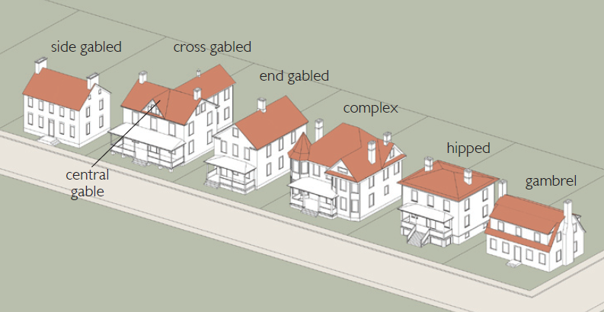
Sec. 84-803.07. – Façade Standards
- Building facades shall reflect the District’s patterns of the surrounding context and provide interest for the pedestrian. Building facades shall reflect and complement the traditional materials and techniques of the historic structures within the Strasburg Historic District and the Shenandoah Valley region. They shall express the construction techniques and structural constraints of traditional, long-lasting, building materials. Simple configurations and solid craftsmanship are favored over complexity and ostentation in building form and the articulation of details.
- Materials - The following materials are permitted.
  - Primary Materials (75% of facade or greater):
    - Brick and tile masonry (or synthetic equivalent)
    - Natural wood shingles or siding
    - Native stone (or synthetic equivalent)
    - Hardie-Plank™ equivalent or better siding
    - Stucco (cementitious finish)
  - Accent Materials (no greater than 10% of facade):
    - Wood trim (or synthetic equivalent)
    - Pre-cast masonry (for trim and cornice elements only)
    - Gypsum Reinforced Fiber Concrete (GFRC—for trim elements only)
    - Metal (for beams, lintels, trim elements and ornamentation only)
    - Architectural style split-faced block (only for piers, foundation walls and chimneys)
- Standards
  - Cornice lines, stringcourses, and other architectural elements shall create a recognizable base, middle, and top to buildings.
  - Façade openings shall not span vertically more than one story, nor shall the horizontal opening measurement exceed the vertical opening measurement. Façade openings shall correspond to interior space.
  - Recessed or projected brick or masonry courses used to emphasize horizontal details of the façade are encouraged in order to avoid a flat appearance of the wall.
Sec. 84-803.08. - Doors and Windows
Doors, windows and other façade openings and bays shall reinforce and maintain the District’s patterns of the surrounding context, and provide interest for the pedestrian.
- Materials
  - Windows shall be of anodized aluminum, wood, clad wood, vinyl, or steel.
  - Window glass shall be clear, with light transmission at the ground story at least 90% and for the upper stories 75%.
  - Specialty windows (one per façade maximum) may utilize stained, opalescent, or glass block.
  - Window screens shall be black or gray.
  - Screen frames shall match window frame material or be dark anodized.
  - Doors shall be of wood, clad wood, or steel and may include glass panes.
  - Shutters shall be wood.
- Standards
  - Window frames (including glass block) shall be recessed at least 2 inches from the exterior face of the building (to avoid a flat appearance to the plane of the wall).
  - Stone or similar materials for window heads (lintels), and sills consisting of accent masonry, precast concrete, soldier, or rowlock brick courses are preferred.
  - Vertical or square orientation for upper story windows is preferred.
  - Windows may be ganged horizontally (maximum five per group) if each grouping is separated by a mullion, column, pier or wall section that is at least seven inches wide.
  - Shutters shall be panel or louvered design and hinge mounted.
Sec.84-803.09. – Gutters and Downspouts

If at all reasonable, gutters shall be installed, repaired or replaced to match the architectural style or era of the dwellings architectural style. Faux materials/modern materials designed to replicate historic architectural designs shall be permitted.

- Wood Gutters, 1600s – 1910s
  - Simple wood gutters often called “Yankee Gutters” or “Box Gutters” have been around for a long time in one form or another. Often the old-growth wood was rot resistant enough to perform admirably for decades and other times the gutters were lined with sheet metal like lead or copper to extend their life.
  - These site-built gutters were often times incorporated into the cornice of old houses so that they seamlessly blended in and went largely unnoticed save for the typically copper downspouts that were also site built and soldered together.
  - The most common designs were a U-shaped or V-shape gutter with a built-up cornice to incorporate the gutter into the design of the house. These gutters while costly to build today can be easily repaired by replacing and rotted or missing wood and with the replacement of the metal lining, they can be given another 100+ years of life.
  - Architectural styles that fit well with the wood gutters would be largely the same group that work with K-style gutters since K-style gutters were an attempt to mimic the look of more traditional wood gutters. Colonial Revival, Greek Revival, Adams & Georgian or other similar styled houses.
  - Exhibits of Wood/Box gutters

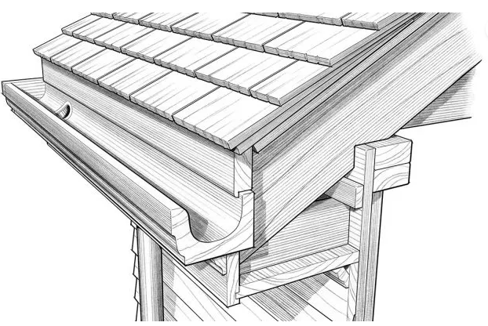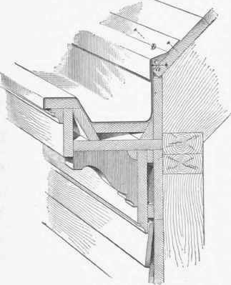

- Cast Iron Gutters, 1820s – 1870s
  - These were never hugely popular due to their weight and difficulty to install, but some houses in the mid-19th-century were fitted with cast iron gutters. With the advent of the Industrial Revolution and the growth of the railroads these new manufactured gutters because more and more available.
  - These were often similar in profile to the K-style gutter or simple U-shaped boxes. Perhaps due to the rust issue that is inherent with cast iron these were never as hugely popular as their predecessors or the wooden gutters of the day that performed better and were easier to make.
  - Exhibits of Cast Iron gutters

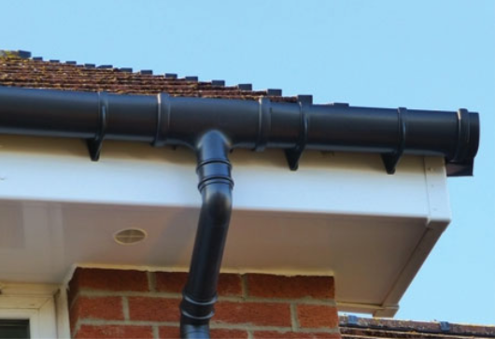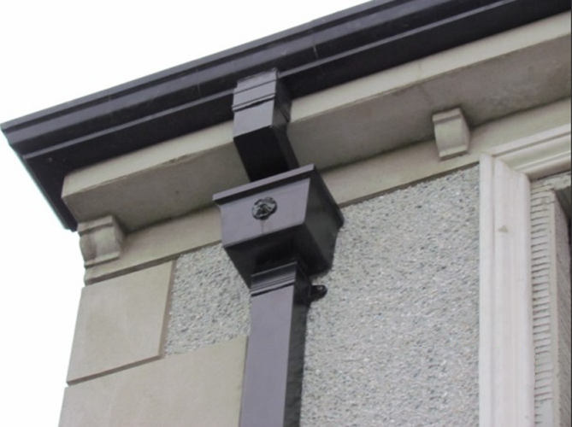

- Half-round Gutters, 1900s – 1960s
  - Half round gutters were popularized in the early 1900s when metal roll machines came into regular use. They are, just as the name implies, a half round design with either a single or double bead rolled edge for added strength.
  - Some of the various materials you could find half round gutters in historically are,
    - Galvanized Steel – The most affordable option these gutters only lasted about 5-10 years before rust began being a problem
    - Galvalume – Steel gutters dipped in molten zinc and aluminum for strength and corrosion resistance this extended the life of gutters to 30 years and beyond
    - Zinc – A premium price and for a premium corrosion resistant material
    - Copper – The gold standard for metal gutters lasting easily 100+ years with minimal to no maintenance.
  - Architectural styles that fit well with the half round would be Bungalow, Victorian, Spanish, Mission, Vernacular, Gothic Revival, other similar styled houses.
  - Exhibits of Half-round gutters

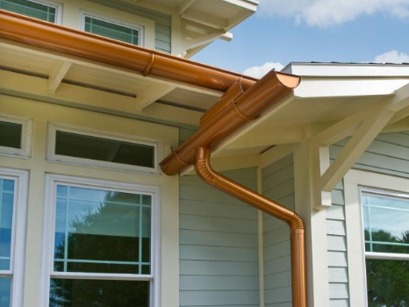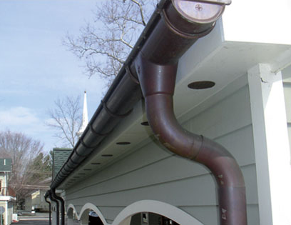

- K-style Gutters, 1950s – Present
  - K-style gutters were invented in the mid-1940s and soon after became the predominate style gutter in America. They are most commonly made from aluminum with a crown molding like ogee profile on the outside face.
  - Architectural styles that fit well with K-style gutters would be Colonial Revival, Greek Revival, Mid-Century Modern, Minimal, Adams & Georgian or other similar styled houses.
  - Exhibits of K-style gutters

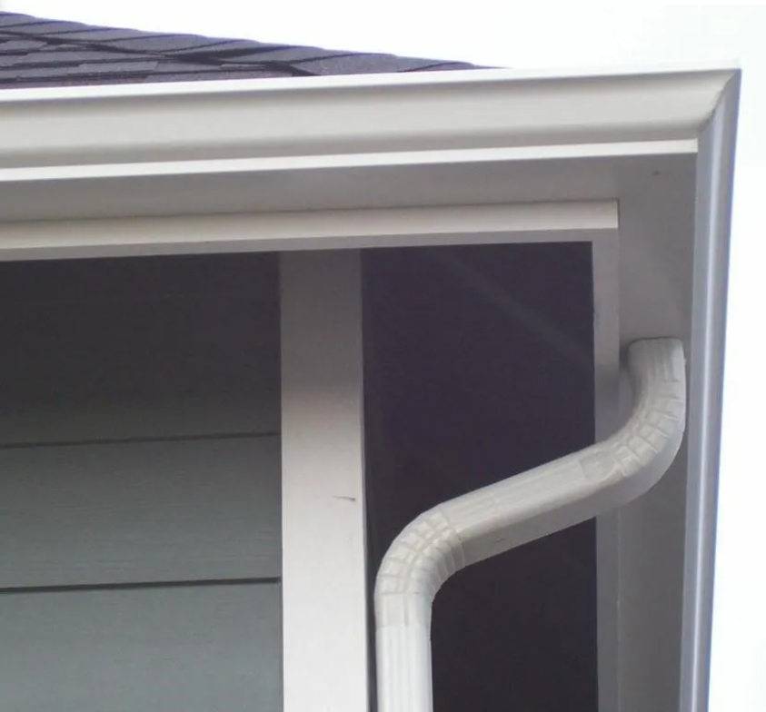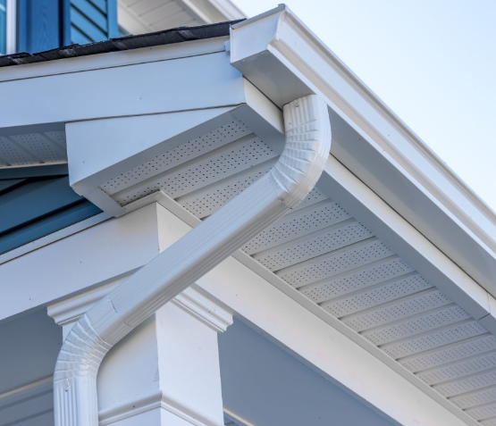

Sec.84-409.10. – Shutters
Sec.84-803.11. – Mechanical Equipment and similar equipment
- New construction - Mechanical equipment, fuel tanks, generators and other similar equipment shall be out of view from the right of way by being located:
  - behind the primary or any accessory structure, or
  - behind full screening of plantings, fencing, or
  - a combination of a and b.
- Additions and rehabilitation of existing dwellings
  - If at all reasonable, equipment location shall comply with subsection 1 above.
Sec.84-803.13. – Existing Buildings and Additions
- Principle
If at all reasonable, buildings that are more than fifty (50) years old shall be encouraged for retention and/or rehabilitation.

- Standards
  - New additions or alterations shall be compatible with the massing, size, scale, rooflines, materials, and architectural features of the original building.
  - Alterations shall not cover, infill, remove or damage significant, original architectural elements of existing buildings that are visible from the street. Such elements include decorative cornices, windows, doors, trim around openings, railings, storefronts and any significant decorative features. Original architectural elements which are in too poor of condition to repair or re-use are preferred to be closely replicated with new elements.
  - New additions shall be placed to the side or rear of existing buildings whenever possible.
  - All building additions shall generally align windows, doors, cornices and other architectural elements with those of the existing building on the primary façade.

PART 804. – COMMERCIAL HISTORIC DISTRICT B-H
Sec. 84.804.01. - B-H Zoning District; Purpose and intent.
The B-H district (formerly CC) is intended commercial land use classifications of the Comprehensive Plan. This district is designed to provide for and encourage development of quality structures primarily of a nonresidential use within the Strasburg Historic District. The commercial general standards identified in Part 500 shall apply unless otherwise amended within Parts 804 through 806.
Sec. 84-804.02. - Uses permitted by right
The following uses are by-right within the B-H zoning district.
- Antique shop
- Arcade, amusement
- Art gallery (private)
- Brewery, Craft
- Business support service
- Butcher shop
- Carpet or flooring retail sales
- Catering, commercial
- Child day center
- Club
- Commercial artist or photographer's studio
- Consumer repair service
- Dance hall
- Dry Cleaning, pick-up
- Dwelling, per Section 84.805.11
- Farmers market
- Financial institution
- Funeral services
- Guidance service
- Hardware store
- Office
- Pawn shop
- Payday loan establishment
- Personal services
- Pet grooming service
- Pet store
- Print shop
- Restaurant, small
- Restaurant, general
- Retail sales
- Retail sales, custom
- Short-term rental/Homestay
- Studio, fine arts

Sec. 84-804.03. - Secondary uses
The following uses shall be permitted by right in the B-H district only in conjunction with a permitted principal use, as specifically identified below, existing or proposed:
- Home office, secondary use to a residential use as identified in Section 84-503.07 and permitted in Part 401 of this chapter.
- Home occupancy, secondary to a dwelling as permitted in Part 401 of this Chapter.
- Live entertainment.
Sec. 84-804.04. - Special uses
The following uses shall be permitted in the B-H district on existing lots of any size with a Special Use Permit:
- Assisted care residence
- Child care facility
- Child day center
- Dwelling Unit, Secondary Family Member
- Religious institution
- Restaurant, mobile where permanent facilities are provided, to include but not limited to restrooms.
- Short-term rental
Sec. 84-804.05. - B-H Development Standards
- Dwellings shall meet the following standards,
  - The minimum lot size shall be 6,250 square feet.
  - The minimum road frontage shall be 45 feet. Frontage shall be maintained to the minimum required front yard setback.
  - There shall be no maximum lot coverage.
  - The maximum building height shall be 35 feet.
Sec. 84-804.06. - B-H Setbacks
- Structures shall meet the following setbacks unless otherwise stated within PARTS 804, 805, and 806.
- For King, Massanutten, and Holiday Streets, the minimum front yard and right-of-way setback is 4 feet, unless otherwise identified within Section 84-805.03.
- For Washington Street, the minimum front yard and right-of-way setback is 10 feet, unless otherwise identified within Section 84-805.03.
- The minimum side yard setback is 0 feet.
- The minimum rear yard setback to include accessory structures, shall be 0 feet, or 10 feet when adjacent to residential district.

PART 805. - B-H COMMERCIAL DISTRICT, DESIGN STANDARDS

Sec. 84-805.01. – Purpose.
- The B-H District encompasses a portion of the Strasburg Downtown Historic District. To ensure the historic elements of this district are maintained, the following standards provides specific information on new structures, additions, alterations and renovations within the district.
- The Town of Strasburg Virginia, Historic District Guidelines is a supporting document to this ordinance for the Residential and Commercial Historic Districts. This document provides further recommended design standards.

Sec. 84-805.02. – Board Review
The Architectural Review Board shall review the following;
- Code Modifications to standards set forth in this Part of the zoning ordinance. Modifications shall be requested by a separate application submitted to the Zoning Administrator.
- Appeals to determinations and decisions made by the Zoning Administrator related to language within Part 408 of this Chapter of the ordinance.
Sec. 84-805.03. – Setbacks.
  - Front setbacks may be reduced to 0 feet when an adjacent structure has a 0-foot setback.
Sec. 84-805.04. - Building Height.
- Building height and building profile, to include parapet walls, for new buildings shall seek to be compatible with adjacent structures.
Sec. 84-805.05. - Front Entrances.
- The business entrance must be prominent and oriented to the street in front of the structure.
- Front entrances to upper floor residential shall be located to the end and shall be designed in a manner to not draw attention or be mistaken of a commercial entrance.
- Duplex dwellings shall have a single entrance located on the front of the structure. This can be achieved by using a front vestibule that serves both units or a second entrance located on the side or rear of the structure.
Sec. 84-805.06. - Parking.
- If provided, all off-street parking shall be provided in the rear yard.
- For new structures on 60 feet or greater, rear parking shall be provide by,
  - Existing alley
  - Side street access
  - Front street access easement/alley
- For new structures on lots less than 60 feet, off-street parking shall be provided unless the Zoning Administrator identifies,
  - All options to provide parking have been exhausted
  - Rear yard vehicle access is not available
- For additions, the addition shall not demolish any existing parking.
Sec. 84-805.07. – Lighting.
- Lighting must never be allowed to shine directly onto adjacent residential properties.
- Security and area lighting shall be shielded from adjacent properties and shall be directed towards the ground.
- Non-color decorative lighting shall be permitted as follows,
  - Framing within show windows.
  - Under awnings and canopies and similar structures.
  - Exterior illumination of signs as permitted in PART 306.
  - Interior open signs no greater than 1 sq. ft.
  - Flashing lights are prohibited.
Sec. 84-805.08. - Design.
- The scale and mass of new or remodeled buildings shall be compatible with adjacent structures. If the structure is wider than 60 the building height and front façade shall be designed to create an appearance of separate structures.
- New structures shall provide building materials that have the same visual appearance as other structures on the block. Other B-H District structures outside of the block may be requested by application to the ARB.
- Architectural styles shall be compatible with other architectural styles on the block. Other B-H District structures outside of the block may be requested by application to the ARB.
Sec. 84-805.09. – Additions.
- The materials and architectural style of additions shall be compatible with the materials and style of the existing structure.
Sec. 84-805.10. – Front features permitted within the public sidewalk area.
The follow shall be permitted within or over the area of the public sidewalk. No structure or sign is permitted to extend beyond the back of the curb and into the roadway right-of-way. All structures and signs shall require an executed Strasburg Hold Harmless Agreement prior to zoning approval. Any broken, damaged, unsafe, unhealthy items that pose a risk to the public shall be removed or repaired immediately.
- Signage as permitted in PART 306.
- Canopies, awnings, balconies and similar structures with 8-foot clearance over the sidewalk surface.
- Window planter boxes without sharp edges on the first floor no greater then 10 inches in depth and does not reduce the clear sidewalk travel way width below 36 inches.
- Window planter boxes on windows above the first floor with 8-foot clearance over the sidewalk surface.
- Decorative features such as potted plants, sculptures and similar items without sharp edges. These items may be placed on the sidewalk within an 18-inch square area on each side of commercial entrances and does not reduce the clear sidewalk travel way width below 36 inches.
Sec. 84-805.11. - B-H residential uses.
- On King, Massanutten, and Holiday Streets, residential uses may be established only on the second or subsequent floor above a commercial use on the first floor of any building constructed in the B-H district. Any use allowed herein is subject to the following:
  - For new structures, parking for a residential use shall be on the same lot as the residential use.
  - For dwelling access located on the side or rear may be by interior or exterior stairwell with access to the public way by alley pedestrian alley a minimum of 4 feet wide, vehicle alley, or parking lot.
  - Dwelling access shall not be shared by or through the commercial use
- On Washington Street, duplex, and apartment uses are permitted and shall include front and side setbacks of 10 feet.
Sec. 84-805.12. – Sidewalk and parking lot uses, general
- All sidewalk or parking lot sales and service locations shall be approved by an approved zoning permit. The zoning permit application shall include;
- A completed zoning permit application,
- A plan showing the proposed location to include configuration of tables, chairs, or other fixtures,
- Hours of use,
- General description of merchandise, services, tables, chairs, or other fixtures related,
- An original/executed Town of Strasburg, Hold Harmless Agreement with the zoning permit application.
- The location of the outdoor display and use area shall not reduce or obstruct pedestrian passage on the sidewalk to less than four (4) feet to the nearest street trees, utility poles, traffic control signs and devices, fire hydrants, buildings, and other similar devices and structures. Furthermore, such placement shall not obstruct vehicular traffic or parking or the use of any crosswalk, wheelchair ramp, bus or taxi zone.
- Any outdoor display of merchandise on a public sidewalk shall permit free access to all buildings and parking areas and comply with access requirements imposed by the Virginia Uniform Statewide Building Code or the Americans with Disabilities Act as the same exists or is hereafter amended.
- Merchandise shall not be placed in or on street furniture, public signage, planter boxes, turf, dirt or landscaped areas or beyond the edge of the business' street frontage.
- Electrical cords, hoses or other materials crossing walkways shall be properly secured, or if temporary, shall be continually supervised until removed.
- No permanent structure may be affixed to the sidewalk or any building.
- The Applicant shall be responsible for any damage caused to any sidewalk or public property.
- Potentially dangerous merchandise such as items with gasoline, kerosene, guns, knives and similar goods shall not be displayed outdoors. Lawnmowers, heaters and similar items that utilize a fuel source shall have empty fuel tanks.

Sec. 84-805.13. – Sidewalk sales and display.
- The maximum amount of sidewalk space dedicated to the display of merchandise may equal 100% of the width of the property frontage adjacent to the sidewalk.
- Displays and merchandise on the sidewalk shall be limited to (5) feet in height.
- Buildings situated on a corner shall also set the display at three (3) feet from the corner of the building to allow for traffic visibility.
- Displays are allowed only during business hours and shall be entirely removed at closing time.
- Displays shall be removed during periods of inclement weather such as high winds or heavy rains during which the display may create a safety hazard.
- Potentially dangerous merchandise such as gasoline, kerosene, guns, knives and similar goods shall not be displayed outdoors.
- This display permit may be subject to revocation if the display is not in compliance.
- No outdoor lighting or live or mechanical music shall be permitted.

Sec. 84-805.14. – Sidewalk café.
- The holder of a sidewalk or outdoor café dining permit shall promptly remove all food dishes and utensils after each customer has left and shall thoroughly clean the entire sidewalk or other outdoor area after the close of each business day.
- A sidewalk or outdoor café dining permit holder shall operate its café dining area only within the area specifically assigned to an operator by a permit issued by the Zoning Administrator. A sidewalk or other outdoor café shall be in operation only during hours that the restaurant or farmers market with which it is associated is open.
- Musical entertainment shall be allowed within any sidewalk café dining permit area; however, such activity shall be limited to un-amplified vocal or instrumental performances and the Town Council may limit the hours during which such entertainment may be conducted.
- No tents or similar structures shall be erected or utilized over or within any sidewalk café.
- The floor of the sidewalk cafe activity area shall be maintained at the same level as the sidewalk, and no alterations to the sidewalk or coverings on the sidewalk shall be installed unless approved by the Zoning Administrator.

Sec. 84-805.15. – Parking lot display.
- Display areas shall not impact vehicle isle ways or pedestrian walkways and access;
- Signs may be required for vehicular direction, i.e. stop, slow, pedestrian crossing, etc.;
- The minimum number of available parking spaces (including handicapped) required by ordinance for the use shall be maintained.
- Merchandise sold must in parking lot displays shall be;
- Sold by a use or tenant that utilizes the parking lot, or;
- Sold by an off-site merchant that acquires a temporary use permit.

PART 806. - B-H COMMERCIAL DISTRICT, ARCHITECTURAL STANDARDS

Sec. 84-806.01. – Purpose
The B-H District encompasses a portion of the Strasburg Downtown Historic District. To ensure the historic elements of this district are maintained, the following standards provides specific information on new structures, additions, alterations and renovations within the district.

Sec. 84-806.02. – Board Review
The Architectural Review Board shall review the following;
- Renovations to existing structures that are not like for like in material and design, to consider alternate materials and designs.
- Demolition of structures visible from the right-of-way
- Code Modifications to standards set forth in this Part of the zoning ordinance. Modifications shall be requested by a separate application submitted to the Zoning Administrator.
- Appeals to determinations and decisions made by the Zoning Administrator related to language within Part 409 of this Chapter of the ordinance.

Sec. 84-806.03. - General Principles, Intent and Specific Standards
These Architectural Standards serve to establish a coherent character for the B-H District and encourage a high caliber, lasting quality of development. Proposed development plans must be reviewed by the Zoning Administrator to verify that they meet these Architectural Standards.
  - The following Principles and Standards shall be applied to all development projects within the B-H District. A statement of Principle precedes each set of Standards, defining the general intent and goals to be achieved.
  - The Standards that follow each Principle define more specific requirements for compliance. The standards are intended to provide some flexibility to the applicant, providing the project meets the general intent of the principle.
  - Definitions, the following definitions shall only apply to this section.
    - Statements that have language such as “shall” or “shall not” are mandatory.
    - Statements that have language such as “preferred” mean that the applicant must comply unless he/she can prove that it is impractical for his/her project, before the Zoning Administrator, based on the following criteria:
      - The physical conditions of the property (e.g. Steep slopes, flood plain, drainage, or small/irregular lot shape) or the existing building features make compliance physically impossible; or
      - The applicant presents an alternative means of compliance that, in the judgment of the Zoning Administrator, meets the applicable principles and complies with the stated goals and standards of the B-H District.
    - Statements that have language such as “encouraged” or “discouraged” mean that compliance is not mandatory, but recommended.
  - These Architectural Standards apply only in conditions where clearly visible from the street-space. Note that the definition of street-space includes parks, civic squares, and civic greens. These standards therefore concentrate on the public space/views from the public space and minimize interference in the private realm.
  - Equivalent or Better - While only materials, techniques, and product types prescribed here are allowed, equivalent or better practices and products are encouraged. They shall be submitted to the Zoning Administrator for review.
  - The Town of Strasburg Virginia, Historic District Guidelines is a supporting document to this ordinance for the Residential and Commercial Historic Districts. This document provides further recommended architectural designs.
Sec. 84-806.04. – New Construction
- New structures and development shall be architecturally designed in a manner that represents the existing structures as follows.
  - For development on King Street, Massanutten Street, or Holiday Street, the architectural design shall create a representation one or a mixture of the structures located at the following parcel addresses,
    - 313 East King
    - 134 North Massanutten
    - 282 East King
    - 278 East King
    - 262 East King
    - 238 East King
    - 229 East King
    - 179 East King
    - 177 East King
    - 160 East King
    - 148 East King
    - 140 East King
    - 137 East King
    - 136 East King
    - 135 East King
    - 134 East King
    - 117 East King
    - 106 East King
    - 168 West King
    - 178 West King
    - 190 West King
    - 195 West King
    - 211 West King
    - 214 West King
    - 234 West King
    - 253 West King
    - 258 West King
    - 263 West King
    - 266West King
    - 276 West King
    - 137 South Holiday
  - For development on Washington Street, the architectural design shall create a representation one of the structures located on King, Holiday, or Washington Streets that resemble a single-family dwelling.
  - The Architectural Review Board may except a code modification for an alternate architectural design.

Sec.84-806.05. – Existing Buildings, Additions, and Accessory Structures.
- Principle
If at all reasonable, buildings that are more than fifty (50) years old shall be encouraged for retention and/or rehabilitation.
- Standards
  - New additions or alterations shall be compatible with the massing, size, scale, rooflines, materials, and architectural features of the original building.
  - Alterations shall not cover, infill, remove or damage significant, original architectural elements of existing buildings that are visible from the street. Such elements include decorative cornices, windows, doors, trim around openings, railings, storefronts and any significant decorative features. Original architectural elements which are in too poor of condition to repair or re-use are preferred to be closely replicated with new elements.
  - New additions shall be placed to the side or rear of existing buildings whenever possible.
  - All building additions shall generally align windows, doors, cornices and other architectural elements with those of the existing building on the primary façade.

Sec. 84-806.06. – Roof Standards
      - Roofs shall reflect the district’s patterns of the surrounding context and provide visual interest to the tops of the buildings, but shall not overwhelm the scale of the street façade.
      - Materials – For flat roofs with parapet walls, any material is permitted. The following materials are permitted for roof surface that is visible from any right-of-way.
        - Clay or concrete (faux clay)
        - Tile (barrel or flat roman)
        - Slate (equivalent synthetic)
        - Metal (standing seam)
        - Dimensional Asphalt shingles
        - Cedar Shingles
        - Cornices and soffits may be a combination of wood, vinyl, and/or metal
- Standards
  - Acceptable roof styles are flat with parapet walls, hipped, gambrel, end-gabled, side-gabled, central-gabled, cross-gabled, and complex.
  - Dormers are permitted
  - Shed roofs (i.e. roofs with a single pitch visible from the street space) shall not be used.)
  - Simple hip, pitched and gable roofs shall be symmetrically pitched between 4:12 and 10:12.
  - Exhibit of roof styles.
Sec. 84-806.07. – Façade Standards
- Building facades shall reflect the District’s patterns of the surrounding context and provide interest for the pedestrian. Building facades shall reflect and complement the traditional materials and techniques of the historic structures within the Strasburg Historic District and the Shenandoah Valley region. They shall express the construction techniques and structural constraints of traditional, long-lasting, building materials. Simple configurations and solid craftsmanship are favored over complexity and ostentation in building form and the articulation of details.
- Materials - The following materials are permitted.
  - Primary Materials (75% of facade or greater):
    - Brick and tile masonry (or synthetic equivalent)
    - Natural wood shingles or siding
    - Native stone (or synthetic equivalent)
    - Hardie-Plank™ equivalent or better siding
    - Stucco (cementitious finish)
  - Accent Materials (no greater than 10% of facade):
    - Wood trim (or synthetic equivalent)
    - Pre-cast masonry (for trim and cornice elements only)
    - Gypsum Reinforced Fiber Concrete (GFRC—for trim elements only)
    - Metal (for beams, lintels, trim elements and ornamentation only)
    - Architectural style split-faced block (only for piers, foundation walls and chimneys)
- Standards
  - Cornice lines, stringcourses, and other architectural elements shall create a recognizable base, middle, and top to buildings.
  - Façade openings shall not span vertically more than one story. Façade openings shall correspond to interior space.
  - Recessed or projected brick or masonry courses used to emphasize horizontal details of the façade are encouraged in order to avoid a flat appearance of the wall.
Sec. 84-806.08. - Doors and Windows
Doors, windows and other façade openings and bays shall reinforce and maintain the District’s patterns of the surrounding context, and provide interest for the pedestrian.
- Materials
  - Windows shall be of anodized aluminum, wood, clad wood, vinyl, or steel.
  - Window glass shall be clear, with light transmission at the ground story at least 90% and for the upper stories 75%.
  - Specialty windows (one per façade maximum) may utilize stained, opalescent, or glass block.
  - Window screens shall be black or gray.
  - Screen frames shall match window frame material or be dark anodized.
  - Doors shall be of wood, clad wood, or steel and may include glass panes.
  - Shutters shall be wood.
- Standards
  - Window frames (including glass block) shall be recessed at least 2 inches from the exterior face of the building (to avoid a flat appearance to the plane of the wall).
  - Stone or similar materials for window heads (lintels), and sills consisting of accent masonry, precast concrete, soldier, or rowlock brick courses are preferred.
  - Vertical or square orientation for upper story windows is preferred.
  - Windows may be ganged horizontally (maximum five per group) if each grouping is separated by a mullion, column, pier or wall section that is at least seven inches wide.
  - Shutters shall be panel or louvered design and hinge mounted.
Sec.84-806.09. – Gutters and Downspouts

If at all reasonable, gutters shall be installed, repaired or replaced to match the architectural style or era of the dwellings architectural style. Faux materials/modern materials designed to replicate historic architectural designs shall be permitted.

- Wood Gutters, 1600s – 1910s
  - Simple wood gutters often called “Yankee Gutters” or “Box Gutters” have been around for a long time in one form or another. Often the old-growth wood was rot resistant enough to perform admirably for decades and other times the gutters were lined with sheet metal like lead or copper to extend their life.
  - These site-built gutters were often times incorporated into the cornice of old structures so that they seamlessly blended in and went largely unnoticed save for the typically copper downspouts that were also site built and soldered together.
  - The most common designs were a U-shaped or V-shape gutter with a built-up cornice to incorporate the gutter into the design of the structure. These gutters while costly to build today can be easily repaired by replacing and rotted or missing wood and with the replacement of the metal lining, they can be given another 100+ years of life.
  - Architectural styles that fit well with the wood gutters would be largely the same group that work with K-style gutters since K-style gutters were an attempt to mimic the look of more traditional wood gutters. Colonial Revival, Greek Revival, Adams & Georgian or other similar styled structures.
  - Exhibits of Wood/Box gutters

- Cast Iron Gutters, 1820s – 1870s
  - These were never hugely popular due to their weight and difficulty to install, but some structures in the mid-19th-century were fitted with cast iron gutters. With the advent of the Industrial Revolution and the growth of the railroads these new manufactured gutters because more and more available.
  - These were often similar in profile to the K-style gutter or simple U-shaped boxes. Perhaps due to the rust issue that is inherent with cast iron these were never as hugely popular as their predecessors or the wooden gutters of the day that performed better and were easier to make.
  - Exhibits of Cast Iron gutters

- Half-round Gutters, 1900s – 1960s
  - Half round gutters were popularized in the early 1900s when metal roll machines came into regular use. They are, just as the name implies, a half round design with either a single or double bead rolled edge for added strength.
  - Some of the various materials you could find half round gutters in historically are,
    - Galvanized Steel – The most affordable option these gutters only lasted about 5-10 years before rust began being a problem
    - Galvalume – Steel gutters dipped in molten zinc and aluminum for strength and corrosion resistance this extended the life of gutters to 30 years and beyond
    - Zinc – A premium price and for a premium corrosion resistant material
    - Copper – The gold standard for metal gutters lasting easily 100+ years with minimal to no maintenance.
  - Architectural styles that fit well with the half round would be Bungalow, Victorian, Spanish, Mission, Vernacular, Gothic Revival, other similar styled structures.
  - Exhibits of Half-round gutters

- K-style Gutters, 1950s – Present
  - K-style gutters were invented in the mid-1940s and soon after became the predominate style gutter in America. They are most commonly made from aluminum with a crown molding like ogee profile on the outside face.
  - Architectural styles that fit well with K-style gutters would be Colonial Revival, Greek Revival, Mid-Century Modern, Minimal, Adams & Georgian or other similar styled structures.
  - Exhibits of K-style gutters

Sec.84-409.10. – Shutters
Sec.84-806.11. – Mechanical Equipment and similar equipment
- New construction - Mechanical equipment, fuel tanks, generators and other similar equipment shall be out of view from the right of way by being located:
  - behind the primary or any accessory structure, or
  - behind full screening of plantings, fencing, or
  - on a roof screened by a parapet wall.
- Additions and rehabilitation of existing dwellings
  - If at all reasonable, equipment location shall comply with subsection 1 above.
Sec.84-806.13. – Existing Buildings and Additions
- Principle
If at all reasonable, buildings that are more than fifty (50) years old shall be encouraged for retention and/or rehabilitation.

- Standards
  - New additions or alterations shall be compatible with the massing, size, scale, rooflines, materials, and architectural features of the original building.
  - Alterations shall not cover, infill, remove or damage significant, original architectural elements of existing buildings that are visible from the street. Such elements include decorative cornices, windows, doors, trim around openings, railings, storefronts and any significant decorative features. Original architectural elements which are in too poor of condition to repair or re-use are preferred to be closely replicated with new elements.
  - New additions shall be placed to the side or rear of existing buildings whenever possible.
  - All building additions shall generally align windows, doors, cornices and other architectural elements with those of the existing building on the primary façade.

PART 807. – DOWNTOWN PARKING OVERLAY DISTRICT (DPO)
Sec. 84-807.01. – Purpose.
The purpose of the Downtown Parking Overlay District (DPO) is to facilitate reinvestment in the Downtown area while also balancing future needs for improved parking options in Downtown.
Sec. 84-807-02. – District Boundaries.
DPO boundaries shall be designated on the official zoning map of the Town of Strasburg. Any property or project partially located within the DPO shall be considered to be fully located within the DPO and subject to the regulations herein.
Sec. 84-807-03. – Existing uses in commercial districts within the DPO.
In commercial districts, commercial structures existing on Aug. 10, 2004, which contain, or may be changed at any future time to contain, any nonresidential use permitted in the commercial district, will not be required to have additional parking spaces above those provided on Aug. 10, 2004. This applies to the reconstruction of nonconforming commercial uses or structures. All new commercial construction on vacant land, or commercial uses begun where no commercial uses existed on Aug. 10, 2004, whether or not such property was previously zoned commercial shall provide the number of spaces required by other sections of this ordinance.
Sec. 84-807.04. – Exemptions allowed within the DPO.
Upon submission of any development application, change of use, or prior to the submittal of either, an authorized agent or landowner may request a reduction or exemption to any portion of Chapter 3 of the Technical Design Manual.
Sec. 84-807.05. – Evaluation of exemption requests.
The Zoning Administrator shall review and make determinations of exemptions. The following factors shall be reviewed taken into account by the Zoning Administrator when reviewing an exemption.
- Adjacent on-street parking
- Adjacent off-street parking that may be utilized with a shared parking agreement.
- Adjacent uses and off-street parking provided for those uses.
- Availability to reorient proposed structures to obtain additional off-street parking.
- Accesses to the property, such as;
- Corner lots
- Alternative access;
- Alleyways
- Access easements
- Change of use with equal or less restrictive parking.
Sec. 84-807.06. – Loading spaces.
If a proposed use requires loading spaces as identified in Chapter 3 of the Technical Design Manual, the applicant shall demonstrate a means to maintain safe passage of any public right-of-way. This may be achieved by the following;
- Off-street loading space on subject property
- Off-street loading space on a separate property with a recorded access easement
- On-street loading space with cones and active flagging. On-street loading shall be prohibited on the following streets;
- King Street
- Queen Street
- Washington Street
- Massanutten Street
- Holiday Street
PART 808. – FLOODPLAIN PROTECTION OVERLAY DISTRICT (FPO)
Sec. 84-808.01. – Purpose.
The purpose of these provisions is to prevent the loss of life and property, the creation of health and safety hazards, the disruption of commerce and governmental services, the extraordinary and unnecessary expenditure of public funds for flood protection and relief, and the impairment of the tax base by:
- Regulating uses, activities, and development which, alone or in combination with other existing or future uses, activities, and development, will cause unacceptable increases in flood heights, velocities, and frequencies.
- Restricting or prohibiting certain uses, activities, and development from locating within districts subject to flooding.
- Requiring all those uses, activities, and developments that do occur in floodplain districts to be protected and/or flood proofed against flooding and flood damage.
- Protecting individuals from buying land and structures which are unsuited for intended purposes because of flood hazards.
Sec. 84-808-02. – District Boundaries.
These provisions shall apply to all lands within the jurisdiction of the Town of Strasburg and identified as being in the 100-year floodplain by the Federal Insurance Administration.
- Floodplain Protection District. Floodplain Protection Districts shall include areas subject to inundation by waters of the 100-year flood. The basis for the delineation of these districts shall be the flood insurance study (FIS) for the Town of Strasburg prepared by the Federal Emergency Management Agency, Federal Insurance Administration, dated July 16, 2003, as amended. Where the specific 100-year flood elevation cannot be determined for this area using other sources of data, such as the U.S. Army Corps of Engineers floodplain information reports, U.S. Geological Survey floodplain quadrangles, etc., then the Applicant for the proposed use, development and/or activity shall determine this elevation in accordance with hydrologic and hydraulic engineering techniques. Hydrologic and hydraulic analyses shall be undertaken only by professional engineers or others of demonstrated qualifications, who shall certify that the technical methods used correctly reflect currently accepted technical concepts. Studies, analyses, computations, etc., shall be submitted in sufficient detail to allow a thorough review by the Town of Strasburg.
- Flood-Fringe Protection District. In the Flood-Fringe and Approximated Floodplain Protection Districts, the development and/or use of land shall be permitted in accordance with the regulations of the underlying area provided that all such uses, activities, and/or development shall be undertaken in strict compliance with the flood proofing and related provisions contained in the Virginia Uniform Statewide Building Code and all other applicable codes and ordinances.
- Approximated Floodplain Protection District. An approximated Floodplain Protection District shall be that floodplain area for which no detailed flood profiles or elevations are provided, but where a 100-year floodplain boundary has been approximated. Such areas are shown as zone A on the maps accompanying the flood insurance study. For these areas, the 100-year flood elevations and floodway information from federal, state, and other acceptable sources shall be used, when available. Within the Approximated Floodplain district, all new subdivision proposals and other purposed developments (including proposals for manufactured home parks and subdivisions) greater than 50 lots or five acres, whichever is the lesser, include within such proposals base flood elevation data. The Applicant shall also delineate a floodway area based on the requirement that all existing and future development not increase the 100-year flood elevation more than one foot at any one point. The engineering principle--equal reduction of conveyance--shall be used to make the determination of increased flood heights.

Sec. 84-808.03. – Compliance and liability.
- No land shall hereafter be developed and no structure shall be located, relocated, constructed, reconstructed, enlarged, or structurally altered except in full compliance with the terms and provisions of this UDO and any other applicable ordinances and regulations which apply to uses within the jurisdiction of this section.
- The degree of flood protection sought by the provisions of this section is considered reasonable for regulatory purposes and is based on acceptable engineering methods of study. Larger floods may occur on rare occasions. Flood heights may be increased by manmade or natural causes, such as ice jams and bridge openings restricted by debris. This UDO does not imply that districts outside the Floodplain Protection District or that land uses permitted within such district shall be free from flooding or flood damages.
- This section shall not create liability on the part of the Town of Strasburg or any officer or employee thereof for any flood damages that result from reliance on this UDO or any administrative decision lawfully made thereunder.
Sec. 84-808.04. – Abrogation and greater restrictions.
This Section supersedes any ordinance currently in effect in floodplain districts; however, any underlying ordinance shall remain in full force and effect to the extent that its provisions are more restrictive than this section.
Sec. 84-808.05. – Enforcement in relation to other district requirements.
- The Floodplain Protection District described above shall be overlays to the existing underlying districts as shown on the official zoning map, and as such, the provisions for the Floodplain Protection District shall serve as a supplement to the underlying district provisions.
- Any conflict between the provisions or requirements of the floodplain districts and those of any underlying district, the more restrictive provisions and/or those pertaining to the floodplain districts shall apply.
- In the event any provision concerning a Floodplain Protection District is declared inapplicable as a result of any legislative or administrative actions or judicial decision, the basic underlying provisions shall remain.
Sec. 84-808.06. – Relation to zoning map.
The boundaries of the Floodplain Protection Districts are established as shown on the flood boundary and floodway map and/or flood insurance rate map, which is incorporated into this section by reference. Said maps shall be kept on file at the Town of Strasburg office. These boundaries shall not be identified on the Town of Strasburg Zoning Map as federal and state requirements may change these boundaries.
Sec. 84-808.07. – District boundary changes.
The delineation of any of the Floodplain Protection Districts may be revised by the Town of Strasburg where natural or manmade changes have occurred and/or where more detailed studies have been conducted or undertaken by the U.S. Army Corps of Engineers or other qualified agency, or an individual documents the need for such change. However, prior to any such change, approval shall be obtained from the Federal Insurance Administration.
Sec. 84-808.08. – Interpretation of boundaries.
- Initial interpretations of the boundaries of the Floodplain Protection Districts shall be made by the Zoning Administrator.
- Should a dispute arise concerning the boundaries of any of the districts, the Board of Zoning Appeals shall make the necessary determination.
- The person questioning or contesting the location of the district boundary shall be given a reasonable opportunity to present his case to the Board and to submit his own technical evidence if he so desires.
Sec. 84-808.09. – Permitted uses within the floodplain protection districts.
The following uses and activities are permitted provided that they are in compliance with the provisions of the underlying area and are not prohibited by any other ordinance and provided that they do not require structures, fill, or storage of materials and equipment:
- Agricultural uses, such as general farming, pasture, grazing, outdoor plant nurseries, horticulture, truck farming, forestry, sod farming, and wild crop harvesting;
- Passive and low impact public and private recreational uses and activities, such as parks, day camps, picnic grounds, golf courses, boat launching and swimming areas, horseback riding and hiking trails, wildlife and nature preserves, game farms, fish hatcheries, trap and skeet game ranges, and hunting and fishing areas;
- Accessory residential uses, such as yard areas, gardens, play areas, and pervious loading areas; and
- Accessory industrial and commercial uses, such as yard areas, pervious parking and loading areas and airport landing strips.
- Fences are prohibited in order to prevent restraining flood debris and create a damning condition.

